Hand Note of Robotics Technology
Dr Pushan Kumar Datta

Assistant Professor
Course Material-Robot Autonomy
Amity University Kolkata

Table of Contents
Chapter 1 - Robotics History, Present Status and Future Trends 1
1.1 What do you mean by industrial Robot? 1
1.2 What is Robotics? 2
1.3 Define programmable automation 2
1.4 Describe three stages of Robotics technology development. 4
1.5 Write the three basic laws of robotics. 7
1.6 What is robot? Is robotics an automation? What is flexible automation? 8
1.7 Draw and explain a basic robotic system. 10
1.8 What do you mean by DOF? How DOF may are required to position an end
effectors at any point in 3-D space? 15
1.9 List at least five types of lower pair connectors with their DOF. 17
1.10 List the major coordinate systems and define each. 20
1.11 What is work envelope? Describe various types of work envelopes. 24
1.12 Explain pitch, yaw and roll of a robot wrist with necessary drawings. 28
1.13 Describe various types of gripping methods with their application areas and drawings. 30
1.14 How many types of power drives are used in Robot? 33
1.15 Draw and describe the pneumatic power drive. 33
1.16 Draw and describe hydraulic power supply. 36
1.17 How many types of controllers are used in robotics? Define each type. 39
1.18 What is the hierarchy of control for servo robots? 41
1.19 Describe motion control of robot. 43
1.20 How many types of controllers are used in robotics? Define each type. 47
1.21 Describe programming methods of a Robot. 49
1.22 What are the advantages and disadvantages of pneumatic power drive? 50
1.23 What are the advantages and disadvantages of Hydraulic power drive? 51
1.24 What are the advantages of hydraulic actuator system over Electrical
motor? 51

Chapter 2 - Robot Kinematics 53
2.1 Describe Robot Kinematics. Describe forward and inverse kinematics scheme. 53
2.2 Discuss Forward and Reverse kinematics of 3DOF Robot arm. 55
2.3 What is A matrix? Deduce matrix for n-DOF manipulator. 58

Chapter 3 - Robot Drives, Actuators and Control 63
3.1 What is the function of FRL unit? 63
3.2 What is an air compressor? 64
3.3 What is the basic difference between a stepper motor and a dc motor? 64
3.4 Draw the cross-section and describe the differential operation of a stepper motor 65

Chapter 4 - Robot End-Effectors 69
4.1 Define and classify robot end effectors 69
4.2 Describe the drive-system for Grippers with diagram 72

Chapter 5 - Sensor and Intelligent Robot 75
5.1 Define sensors. Give examples. 75
5.2 Briefly describe different types of sensors used in robotics. 76
5.3 Define sensor. Describe five important characteristics of a sensing device 80
5.4 Discuss position and displacement sensors. 82
5.5 What is LVDT? Draw and discuss. 85
5.6 What is Artificial skin? How it works? 87
5.7 Define range and proximity sensor. 88
5.8 Describe various types of Electro-optical imaging sensors. 91
5.9 Write short note on acoustic sensor. 92
5.10 Describe Robot vision. Describe three functions of its operation. 93
5.11 List the operation under lower and higher vision. 96
5.12 What is a high level vision? 96
5.13 Distinguish between low level and high level vision. 97

Chapter 6 - Robot Language and Programming 98
6.1 Describe various Robot Programming languages. Mention their developers and their relative merits and demerits. 98
6.2 Discuss the classification of Robot languages. 107
6.3 List and explain three basic modes of operation of a robot. 109
6.4 Describe Monitor Commands 111
6.5 Describe Program Instruction. 114

ENGINEERING PPT: Robotics and Intelligent Systems PDF Lecture Slides (engppt.com)

Chapter 1
Robotics History, Present Status and Future Trends

  - What do you mean by industrial Robot?
- Industrial Robot
    - Industrial robotics is the discipline concerning robot design, control and application in industry, and its products have by now reached the level of a mature technology.
    - The connotation of a robot for industrial applications is that of operating in a structured environment whose geometrical or physical characteristics are mostly known a priori.
    - Hence, limited autonomy is required.
    - The early industrial robots were developed in the 1960s, at the confluence of two technologies:
- Numerical control machines for precise manufacturing, and
- Teleoperators for remote radioactive material handling.
- During the subsequent decades, industrial robots have gained a wide popularity as essential components for the realization of automated manufacturing system.
- The main factors having determined the spread of robotics technology in an increasingly wider range of applications in the manufacturing industry are
- Reduction of manufacturing costs,
- Increase productivity,
- Improvement of product quality standards, and
- The possibility of eliminating harmful or off-putting tasks for the human operator in a manufacturing system.
- By its usual meaning, the term automation denotes a technology aimed at replacing human beings with machines in a manufacturing process, as regards
  - Not only the execution of physical operations
  - But also the intelligent processing of information on the status of the process.
- Three levels of automation one may refer to are
  - Rigid automation,
  - Programmable automation, and
  - Flexible automation.
- Therefore a robot is a machine that carries out the tasks done by a human being.
  - A robot may do assembly work where some sort of intelligence decision- making capability as expected from a man is needed.
  - A robot sometime does heavy work and automatically performs the same task repetitively.
  - An Industrial Robot has been defined as a reprogrammable multifunctional manipulator designed to move material, parts, tools or specialized devices through various programmed motions for the performance of a variety of tasks.

  - What is Robotics?
- Robotics
  - Robotics is the Science of designing and building robots suitable for real-life applications in automated manufacturing and other nonmanufacturing environments.

  - Define programmable automation.
- Programmable Automation
  - With the revolution of technology, human works are replaced by automatic machines.
  - Thus automation technology becomes popular in
  - Industry,
  - Office works and
  - Even in homes.
A new type of automation technology has become available that is adjustable, adaptable and flexible enough not only to the change in the design of the product, but also to the change in the process of manufacture of the products.
- This type of automation is termed as Programmable automation
- Here Programmable means that one set of tasks can be easily switched over to another set by changing the computerized instructions.
- In programmable automation, attempts have been made to combine consistency and flexibility.
- Programmable automation consequentially reduces the very high costs involved in the changeover to another custom-made capital intensive machine.
- The birth of flexible automation has been possible with the advent of
  - Microelectronics,
  - Microcomputers and
  - Programmable controllers.
When a machine is made to act or perform tasks similar to those done by a human being in sub-human working environment, it has to be flexible.
- Around 1950, automation took a new turn with the introduction of numerical controlled (NC) machines.
- But NC machines are hardware based machines.
- To make these more compatible with the software based system, computer numerically controlled (CNC) machines have been evolved.
- Each NC machine is provided with a minicomputer or a microcomputer.
- They are easily programmable through their software.
- They are suitable for batch quantity production where products often undergo either design change or process change.
- Software packages are developed to accommodate different programs or routines in the storage medium of magnetic tape or disc and thus various tasks can be performed according to the sequence laid down in the process sheets.

Programmable automation uses information technology and numerical engineering to provide coordination, machine control and communication through computers in the most effective way.
- It attempts to bridge the gap between consistency and flexibility.
    - An Example of Programmable Automation technology is the robot.

  - Describe three stages of Robotics technology development.
- Historical Background
    - Robots have their historical past though they came into existence only in 1961 when Unimation Inc., USA introduced the first servo-controlled industrial robots.
- The background, however, can broadly be divided into three stages, namely,
  - Ancient and post historic ages,
  - Post-industrial renaissance age and
  - Microelectronics and microprocessor age.

- Ancient and Post Historic Ages
- Early discoveries in the ancient historic age dated back to 5000 B.C., when during the Indus-Valley civilization (Indian-Pakistan), many human and animal-like figures and automatic puppets were made to imitate the movements of wild animals and birds.
- In the period around 3000 B.C., water clocks were built by Egyptians.
- Around the same time, the Chinese also built many amusing devices that depicted sequential motions.
- About 500 B.C., Herodotus recorded how a bonded labourer lost his feet and later his feet had been replaced by prosthetic wooden feet.
- In the later period, the Romans also made some prosthetic hands for the victims of war.
- In 400 B.C., Archytas of Tarentum made a wooden pigeon which could fly, and during the Middle ages, numerous instances of constructing automata were recorded.
- German astronomer Johann Miller made an iron fly, able to flutter around the room and return to his hand; later he fabricated an eagle that flew before the Emperor Maximilian when he entered Nurnbery

- Post-Industrial Renaissance Age
- In the age of industrial revolution, steam power became the main source of energy.
- Various types of machines gave a new trust to the concept of mechanization like
    - textile,
    - drilling,
    - boring,
    - milling machines.
- In 1805, J.M. Jacquard introduced an automatic loom with punched card control mechanism.
- In 1823, Charles Babbage’s attempt to build a machine for calculating mathematical tables brought a scientific outlook to the existing technological skill.
- In the subsequent periods, many automation elements were invented and introduced with the prime object of providing relief to man in his struggle against painful and strenuous work.
- Some of the ideas were to relieve man form the hazards involved in handling heavy and odd jobs.
- Automation found wide applications in spray painting in this age.
- In the 1940, a great many inventions were made and new ideas brought in.
- Remote teleoperated master-slave manipulators were developed around 1944 by Roy C. Goerz at the Argonne National Laboratory in the USA.
- The atomic age accelerated the growth of teleoperators.
- In the teleoperated systems, the slave manipulator was actuated by the master arm to handle radioactive materials from a safe distance.

- Microelectronics and microprocessor age
- Electronic computer ENIVAC, IBM701 etc. and NC machine tools became a turning point in the development of robotics.
- A battery operated mechanical man was made in Stanford University, USA.
- That could walk from room to room, identify some items and able to introduce its battery charger plug to a nearby electric socket.
- In 1959, The planet corporation introduced a pick and place robot.
- In 1961, Unimation Inc., USA introduced the first industrial robots and Intel introduced microprocessor technology.
- Gradual development of robotics introduced MarkII in 1967, “Shakey” with AI by stanford research Institute in 1968, A rectangular coordinate robot, IBM 7565 by IBM in 1972 and Cincinnati Milacron was introduced T³, the first computer controlled robot in 1974.
- Stanford and IBM introduced “structured light” vision system and WAVE, the first robot programming language was developed in Stanford in 1971. Another robot programming language AL was developed in 1974.
- In 1996, Space hunting of robots started Viking-I robot rover, built by NASA, landed on Mars. BARPY speech understanding system was completed at Carnegie Melton by Reddy.
- First PUMA prototype, based on Scheinman's MIT model arm was built for General Motors in 1978.
- The largest academic robot lab in the US, the Robotics Institute at Carnegie Melton was established and First robot to pick randomly stacked connecting rods out of a bin was developed at the University or Rhode Island in 1980.
- In 1983-84, Southerland's hexapod of Carnegie Melton University-the first mancarrying computer-controlled walking machine by Raibert (1983) and Southerland and Ullner (1984). BIPER-4-A two-legged walking machine designed by Miura-Shimoyana.
- In last two decades the invention in robotics spreads in multidimensional sectors.
- Misubishi introduces Robot dog and Honda build a Humanoid with latest intelligent technology.
- Several robots and robotic systems were built to work in space.
- Various robotic systems like Drone fighter plane were introduced in war sectors.

  - Write the three basic laws of robotics.
- Laws of Robotics
- Sir Isaac Asimov dealing on the subject of robotics framed three basic laws which the robotocists still obey with respect.
- The laws are philosophical in nature.
- They are as follows:
First Law : A robot must not harm a human being or, through inaction, allow one to come to harm.
Second Law : A robot must always obey human being unless it is in conflict with the first law.
Third Law : A robot must protect itself from harm unless that is in conflict with the first and/or the second laws.

  - What is robot? Is robotics an automation? What is flexible automation?
- Robot Definition
- Robots are the means of
  - performing multifarious activities for man’s welfare in the most planned and integrated manner,
  - maintaining their own flexibility to do any work,
  - effecting enhanced productivity,
  - guaranteeing quality,
  - assuring reliability and
  - ensuring safety to the workers.

- The robot is an essential component of CAM (Computer Aided Manufacturing) and CIM (Computer Integrated Manufacturing) technologies.
- The name robot came from the Czechoslovakian word Robota which means a worker or a slave doing heavy work.
- Therefore a robot is a machine that carries out the tasks done by a human being.
- A robot may do assembly work where some sort of intelligence decision- making capability as expected from a man is needed.
- A robot sometime does heavy work and automatically performs the same task repetitively.
- An Industrial Robot has been defined as a reprogrammable multifunctional manipulator designed to move material, parts, tools or specialized devices through various programmed motions for the performance of a variety of tasks.

- Robot is a manipulator that is
  - Reprogrammable and
  - Multifunctional.
    - The reprogramability has got its meaning only when a computer or a microprocessor is interfaced with it; it is through this computer that programmed instructions can be written and fed, and also if necessary, it can be edited to have a new program and information.
    - It is multifunctional in the sense of its versatility.
    - It can perform various activities; sometimes
  - it can use an end effectors to move raw materials for further processing into the final product;
  - it can transfer or handle parts;
  - it can also actuate some of the tolls like
    - Painting gun for spray painting,
    - Welding gun for welding and
    - Drill or reamers for machining and finishing operations.
- It may also
  - hold some specialized devices for working in an unstructured environment,
  - handling radioactive materials or assembling components of a job.
- The robot has a mechanical configuration called the manipulator arm with a gripper at its free end to move from point or in a continuous path following some trajectory with or without feedback sensing elements.

- Robotics is an automation
- Robotics is an automation as well as programmable too called Programmable Automation.

- Automation
  - In (hard) automation, the machine performs a particular job only in the designed sequence, while a robot can be made to do different jobs at different times and in different sequences.
  - This can be done by programming.
  - A robot can be reprogrammed to change the sequence of tasks while a fixed machine set to perform certain tasks in sequence cannot be programmed.
  - A fixed automated machine cannot take any decision if any change is required in the environment.
  - An automated machine does not have sensory feedback to reprogram the predetermined path.
  - An automated machine has neither a “knowledge base” nor intelligence.
  - At best, an automated machine can be made to adapt to slight changes in a known environment, as in the case of a few NC machine tools.
  - So robot is more than an automated machine or equipment.

- Flexible Automation
      - The birth of flexible automation has been possible with the advent of
- Microelectronics,
- Microcomputers and
- Programmable controllers.
- When a machine is made to act or perform tasks similar to those done by a human being in sub-human working environment, it has to be flexible.

  - Draw and explain a basic robotic system.
- Robotics Systems and Robot Anatomy
  - A system is an integrated whole of parts or subsystems.
  - A system has a specified goal or output for a given set of inputs; a system may have many goals as well.
  - A robot is a system as it combines many subsystems that interact among themselves as well as with the environment in which the robot works.
  - A robot has many components which include:

- A base-fixed or mobile.
- A manipulator arm with several degrees of freedom (DOF).
- An end-effector or gripper holding a part or a tool.
- Drives or actuators causing the manipulator arm or end-effector to move in a space.
- Controller with hardware and software support for giving commands to the drives.
- Sensors to feed back the information for subsequent actions of the arm or gripper as well as to interact with the environment in which the robot is working.
- Interfaces connecting the robotic subsystems to the external world.

- A robot has some specific objective
    - It may be designed for simply picking up and placing the workpieces.
    - It may be employed to interact with and work load a lathe, a milling machine or any equipment, or it may also perform some assembly work.
    - To accomplish the job, a robot must have a suitable manipulator arm with specified coordinate systems to attain a designed reach in the working space.
    - It should have
      - a suitable gripper to match the geometry of the workpiece to be handled;
      - a suitable control system with or without servo mechanisms for sending signals to the drives, or
      - permitting storage of programmers and data for desired signals to the drives, or
      - permitting storage of programs and data fro desired path planning with adequate speed and good accuracy.
    - The robot may have some sensors to feedback information for modifying the motion or path.
    - The controller is provided with interfacing units connected to external equipment in the outside world.
    - Figure 1.1 indicates a scheme of a robotic system.

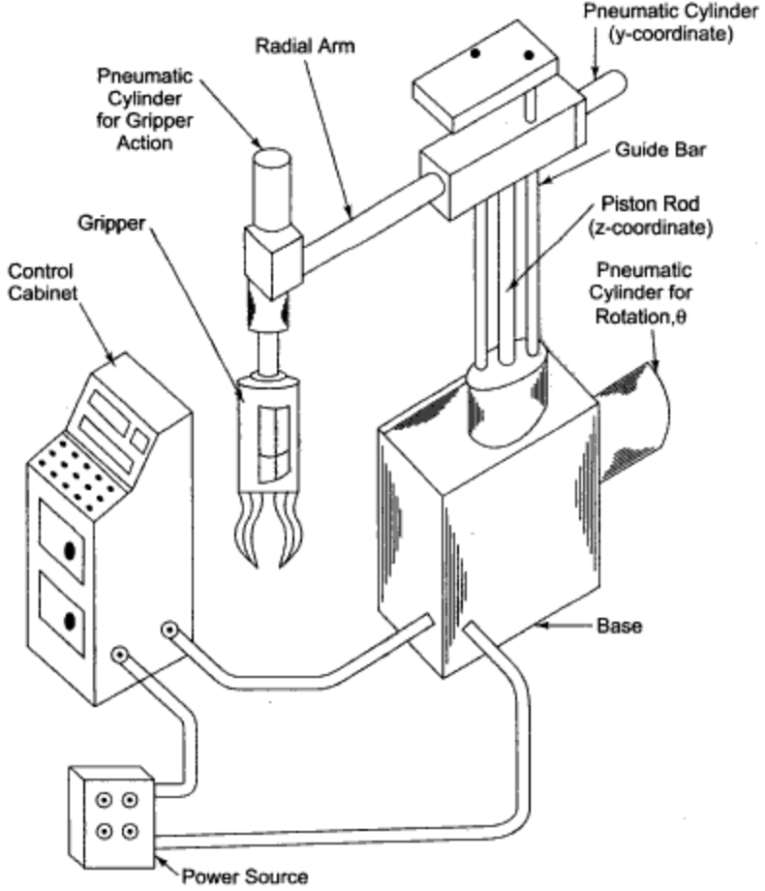
Fig. 1.1 A robotic system

    - It consists of
      - a manipulator,
      - a gripper,
      - a controller, and
      - a power source

        - Figure 1.2 indicates the basic components of a microprocessor-based pneumatic robot system.

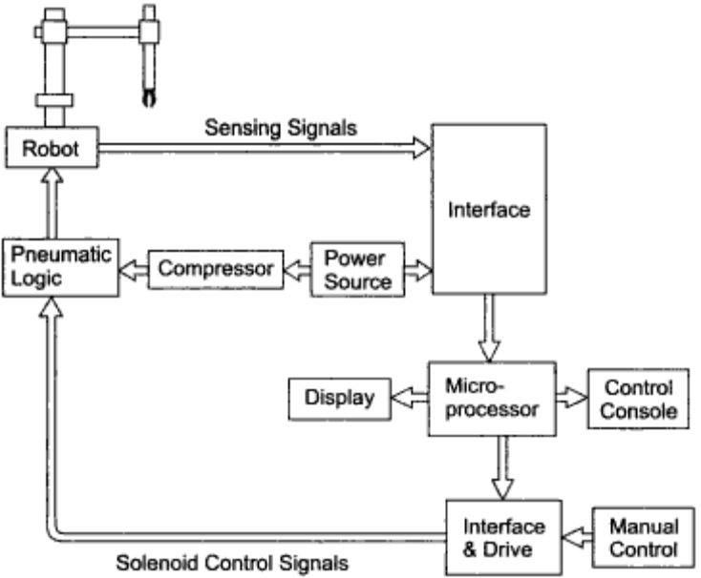
Fig. 1.2 Basic components of a microprocessor-based robotic system

- Figure 1.3 shows a popular model of computer controlled Unimation-Puma robot.
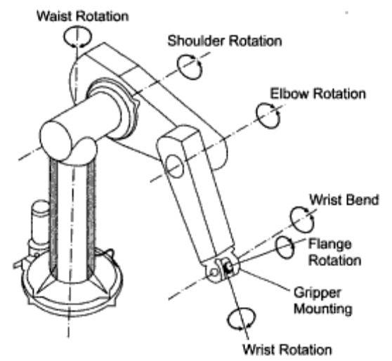
Fig. 1.3(a) Six axes Puma manipulator
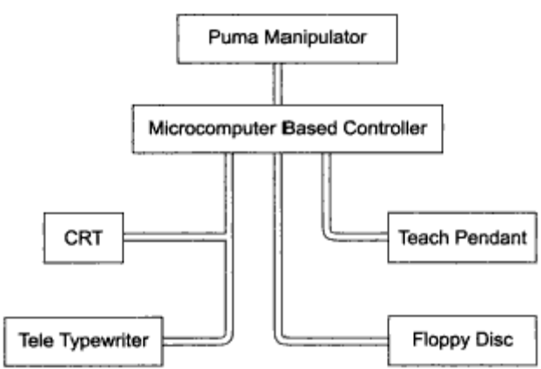
Fig. 1.3(b) A scheme of computer controlled Puma robotic system

- Figure 1.4 shows Cincinnati Milacron 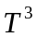 robotic manipulator indicating six degrees of freedom-
  - Arm sweep,
  - Shoulder swivel,
  - Elbow extension,
  - Wrist pitch, and
  - Wrist yaw and wrist roll.

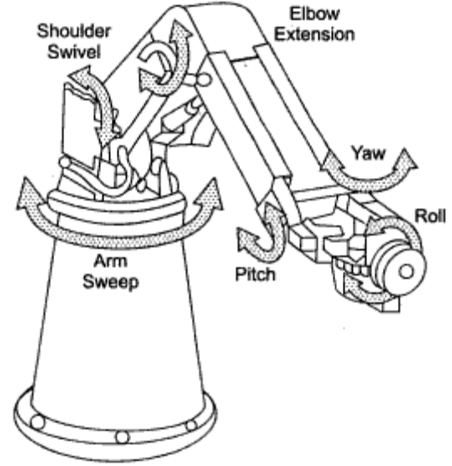
Fig. 1.4 The Cincinnati Milacron robot.

  - What do you mean by DOF? How DOF may are required to position an end-effectors at any point in 3-D space?
- Robotic Manipulator Arm
  - The most obvious mechanical configuration of the robot is the manipulator arm.
  - There are several designs of the arm to facilitate movement with in work envelope with maximum possible
  - load,
  - speed,
  - high precision and
  - repeatability.

- Degree of Freedom (DOF)
  - The simplest robot may be a two or three-axes arm.
  - The axis is meant to understand independent movement or degree of freedom (DOF).
  - 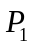, 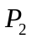and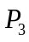 are the three DOFs indicating translation or location of hand and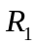, 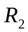andare the three DOFs of orientation of the object.
      - Robots are built with several degrees of freedom that may vary from two to ten.
      - Most of the industrial robots have, of course, five or six degrees of freedom.
      - A typical robotic manipulator arm suitable for remote purpose operations is illustrated in Figure 1.5.

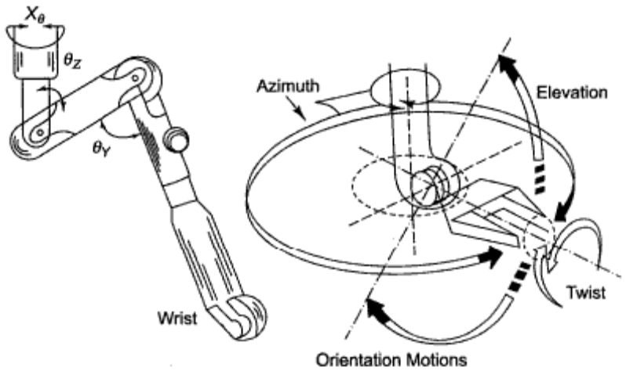
Fig. 1.5 A manipulator arm for remote purpose operations

      - It has 3 degrees of freedom for locating or positioning the object and 3 degrees of freedom for orienting the same.

- A robotic manipulator arm consists of several separate links making a chin.
          - The manipulator is located relative to the ground on either a fixed base or on a moveable base.
          - The base may be a mobile one and may have some transportation system.
          - The manipulator arm has a free-end where
  - An end-effector or gripper or
  - Sometimes a specialized tool holder (for holding, say, a welding gun) or
  - Any powered device (say, a drill) is attached.
          - In a fixed base, 6 degrees of freedom robot, the first three links of the manipulator constitute the body and they help to place the end-effector at a desired location inside its work environment or working volume.
          - The remaining three links make up the wrist of the manipulator and are used to define the orientation of the manipulator end points.
          - It is therefore important to know the types of the linkages used in the base-body-wrist-end effector complex in the manipulator work environment system.

  - List at least five types of lower pair connectors with their DOF.
- Lower Pair Connectors
  - A robot is essentially a moveable open chain of successively coupled bodies with one end fixed to the ground and the free end containing an end effector.
  - The bodies of the open chain are usually links which are joined together by some lower pair connectors.
  - The most common types of lower pair connectors are:
- Revolute pair (1 DOF)
- Prismatic pair (1 DOF)
- Cylindrical pair (2 DOF)
- Spherical pair (3 DOF)
- Hooke joint (2 DOF)

- Revolute pair (1 DOF)
        - The revolute pair ( R )as shown in Figure 1.6
- Permits relative rotation about a unique pair axis and
- Has a single degree of freedom.

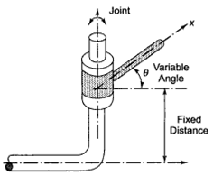
Fig. 1.6 Revolute pair (R)

- Prismatic pair (1 DOF)
- The prismatic pair (P) as shown in Figure 1.7
  - Allows relative sliding parallel with a unique pair axis and
  - Has one degree of freedom.

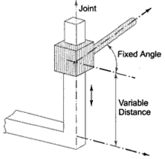
Fig. 1.7 Prismatic pair (P)

- Cylindrical pair (2 DOF)
  - The cylindrical pair ( C ) illustrated in Figure 1.8
  - Permits independent relative rotation about and relative sliding parallel to a pair axis and
  - It has two degrees of freedom.

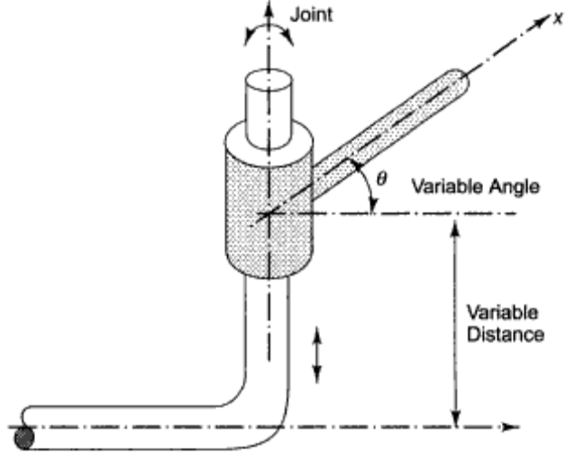
Fig. 1.8 Cylindrical pair (c)

- Spherical pair (3 DOF)
  - The spherical pair ( S ) as shown in Figure 1.9 is a ball and socket joint that
  - Permits relative rotation about three non-coplanar interacting axes and
  - Has three degrees of freedom.

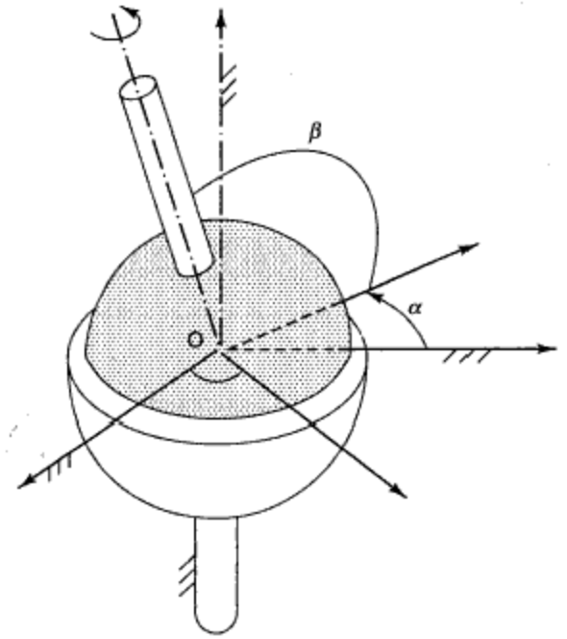
Fig. 1.9 Spherical pair (s)

- Hooke joint (2 DOF)
  - Hooke’s joint ( T) as shown in Figure 1.10
  - Permits independent rotation about: two intersecting axes offset by an angle and
  - Has two degrees of freedom.

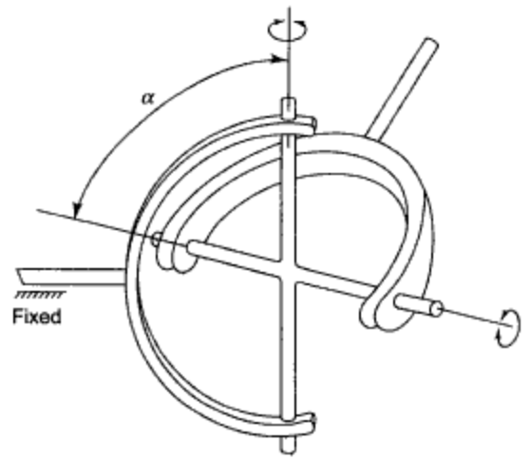
Fig. 1.10 Hooke’s joint

- However, the most basic joints are the one-DOF revolute pair ( R ) and one DOF prismatic pair ( P ) and these two pairs are extensively used in combination in the robotic manipulators.

  - List the major coordinate systems and define each.
- Robot Coordinate System
  - There are some major coordinate systems based on which robots are generally specified.
  - The common designs of robot coordinates are
  - Cartesian coordinate system,
  - Cylindrical coordinate system,
  - Polar or spherical coordinate system, and
  - Revolute coordinate system.

- Cartesian Coordinate System
  - In the Cartesian coordinate configuration shown in Figure 1.11, the three orthogonal directions are X, Y and Z.

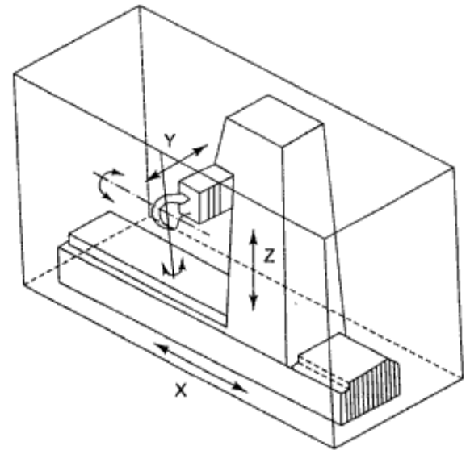
Fig. 1.11 Cartesian Coordinates

  - X-coordinate axis may represent left and right motion; Y-coordinate axis may describe forward and backward motion; Z-coordinate axis may be used to represent up and down motions.
  - Motion in any coordinate axis can be imparted independently of the other two.
  - The manipulator can reach any point in a cubic volume of space.
  - It allows three DOFs (x, y, z) in translation only.

- Cylindrical Coordinate System
      - In cylindrical coordinate configuration shown in Figure 1.12, the three degrees of freedom -two linear motions and one rotational- correspond to a radial in or out translation r,
        - an angular motion, θ about the vertical axis, and
        - z, a translation in the z-direction that corresponds to the up or down motion.

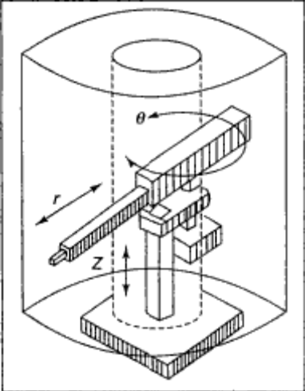
Figure 1.12 Cylindrical Coordinates.

      - The manipulator can ideally reach any point in a cylindrical volume of space.
      - In reality, the robot cannot rotate through a complete circle in the space bounded between two cylinders.

- Polar or Spherical Coordinate System
          - In the spherical coordinate configuration shown in Figure 1.13, the robot has
        - one linear and
        - two angular motions.

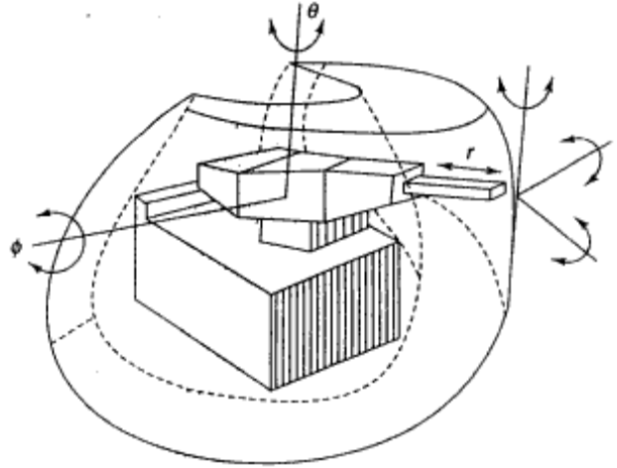
Figure 1.13 Spherical Coordinates

          - The linear motion, r corresponds to a radial in or out translation,
        - The first angular motion corresponds to a base rotation, θ about a vertical axis, and
        - The second angular motion, ф is the one that rotates about an axis perpendicular to the vertical through the base and is sometimes termed as elbow rotation.
          - The two rotations along with the in or out motion enable the robot to reach any specified point in the space bounded by an outer and inner hemisphere.
          - Sometimes, the spherical coordinate system is referred to as the polar coordinate system.

- Revolute Coordinate System
  - In the revolute coordinate, that is, anthropomorphic or jointed arm configuration as illustrated in Figure 1.14, a robot uses three rotations.
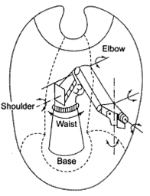
Fig. 1.14 Revolute coordinates

  - The anthropomorphic design corresponds to the design of a human arm having waist, shoulder and elbow joints.
  - The link of the arm mounted on the base joint can rotate around the base about the Z-axis and the two links, namely the shoulder and the elbow.
  - The shoulder can rotate about a horizontal axis and the elbow motion may either be a rotation about a horizontal axis or may be any location in space depending on the rotational motions of the base and the shoulder.
  - The anthropomorphic robot can move in a space bounded between a spherical outer surface and inner surface having scallops due to the constraints of the joints.

- A simple way to define the manipulator body or arm in terms of lower pair connectors is to represent the robots
  - In a rectangular coordinate system as P-P-P robot,
  - In a cylindrical coordinate system as P-R-P robot,
  - In a spherical coordinate system as R-R-P robot, and
  - In a revolute coordinate system as R-R-R robot.

  - What is work envelope? Describe various types of work envelopes.
- Work Envelope
- The volume of space surrounding the robot manipulator is called the work envelope.
- Accordingly, the work envelope for
  - The rectangular coordinate robot,
  - The cylindrical coordinate robot,
  - The spherical coordinate robot and
  - The joined arm (revolute) coordinate robot
are different due to the different movement of the arm.

- The Rectangular Coordinate Robot
- The work envelope of a rectangular Cartesian coordinate robot is shown in Figure 1.15.
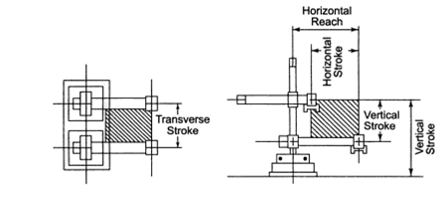
Fig. 1.15 Work envelope of a Cartesian coordinate robot

- The elevation view indicates the vertical and horizontal reach obtained due to the rise and fall of the arm on the vertical column and in and out positions of the robot’s arm.
- The plan view also shows a rectangle due to the combined action of the sliding of the arm on the horizontal axis and the transverse stroke.
- The work envelope of a rectangular coordinate robot is a parallelepiped.

- Application
  - Rectangular coordinate robot is very rigid and suitable for pick and place operations in hot environment as in a furnace.
  - It is also a suitable manipulator for overhead operations as it covers a large work area.

- The Cylindrical Coordinate Robot
      - The work envelope of the cylindrical coordinate robot is indicated in Figure 1.16.
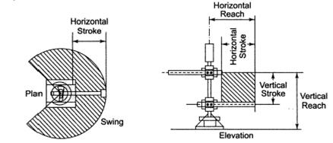
Fig. 1.16 Work envelope of a cylindrical coordinate robot

      - The elevation view indicates the vertical and horizontal reach.
      - The vertical and horizontal strokes combine to form a rectangle-section.
      - The plan view indicates the robot arm pivoted at the centre of the base which can form a portion of a circle by the action of swing.
      - The plan view also shows the horizontal reach.
      - Thus, the work envelope of a cylindrical coordinate robot is a portion of a cylinder.

        - Application
          - Cylindrical coordinate robot is suitable for handling parts in the machine tools or other manufacturing equipment.
          - It cannot pick up objects from the floor on which the robot is mounted.

- The Spherical Coordinate Robot
              - Spherical (or polar) coordinate robot encompasses an envelope shown in Figure 1.17.

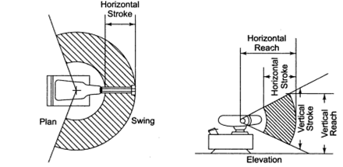
Fig. 1.17 Work envelope of a spherical coordinate robot

              - The elevation view indicates the vertical reach and the horizontal reach.
              - Unlike the cylindrical coordinate robot that makes up and down motions on the vertical axis, the polar coordinate robot is pivoted and forms an arc while the horizontal stroke extends from the inner circle to the outer circle in the elevation view.
              - The plan view indicates a swing of the robot’s arm as it is rotated around its base.
              - The work envelope of the extension arm of spherical coordinate robot is the volume swept between two partial spheres.

- Application
- Spherical coordinate robots are most suitable for transferring parts on machine tools.
- They are suitable for picking components from the floor.
- They are extensively used in flexible manufacturing systems.

- The Joined Arm (Revolute) Coordinate Robot

    - The work envelope of a revolute or joined arm coordinate robot is shown in Figure 1.18.

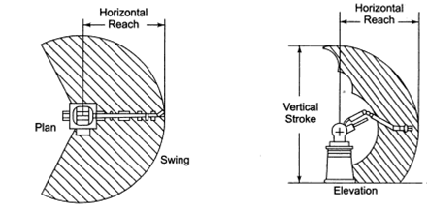
Fig. 1.18 Work envelope of a jointed-arm coordinate robot

    - The elevation view indicates a complex work envelope that is swept by the combined motion of the waist, elbow and wrist of the manipulator.
    - The vertical and horizontal reaches are also shown in the elevation view.
    - The plan view indicates the same swing as shown in the plan view of the cylindrical coordinate robot.
    - Joint arm robot is flexible and versatile as it can easily reach up and down and can also swing back.
    - The joints are all rotary.

- Application
        - This type of anthropomorphic robot is suitable for loading and unloading components or tools in CNC machines and machining centre, and finds wide applications in forging and metal working industry.

  - Explain pitch, yaw and roll of a robot wrist with necessary drawings.
- Robot Wrists

  - It has been mentioned that the 3-DOFs of the robot arm permit it to locate or position an end-effector at any point in 3-dimensional space in its working envelope, but to orient the end-effectors properly with respect to the task to be performed, it is required to have three additional DOFs in general.
  - A wrist may have three to five degrees of freedom to solve the problem of orientation.
  - Three rotational freedoms of the wrist are usually designated as
  - Pitch,
  - Yaw and
  - Roll
as they are very popular terms uses in aviation.

- Pitch
  - A pitch is defined as rotation about a horizontal axis and it is with this pitch motion, an aircraft is able to move its nose up or down.
  - Figure 1.19a shows the pitch motion of a robot wrist.

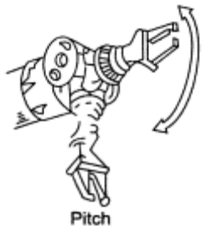
Figure 1.19a

- Yaw
- Yaw is a rotational movement about the vertical axis and this motion moves the nose of the aircraft to the left or right.
- Figure 1.19b shows the Yaw motion of a robot wrist.

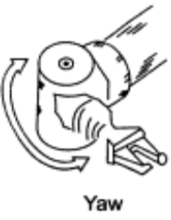
Figure 1.19b

- Roll
- A roll is a rotational freedom about the aircraft's own axis.
- With the roll motion, a craft can turn about its own axis.
- This concept has been extended to the design of the robot end-effectors attached to the wrist.
- Figure 1.19c shows the Roll motion of a robot wrist.

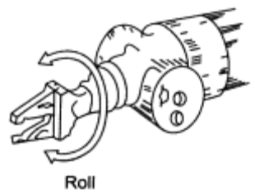
Figure 1.19c

- Figure 1.20 shows the pitch, yaw and roll motions of a robot wrist.

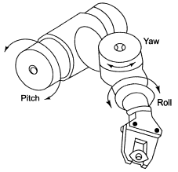

Figure 1.20 A robot wrist indicating pitch, yaw and roll motions.

  - Describe various types of gripping methods with their application areas and drawings.
- Robot End-Effectors
- Robot end-effector is the gripper or end-of-arm tooling mounted on the wrist of the robot manipulator arm.
- A robot performs a variety of tasks for which various tooling and special grippers are required to be designed.
- A robot manipulator is flexible and adaptable, but its end-effector is task-specific.
  - A gripper designed for picking up a tool to be fitted to a CNC machine tool is not suitable for welding a railway wagon.
    - The wide range of gripping methods include
      - Mechanical clamping,
      - Magnetic gripping, and
      - Vacuum (suction) gripping.

        - Mechanical Clamping
          - A mechanical gripper is an end-effector that uses mechanical fingers actuated by a mechanism to grip an object.
          - The fingers are the appendages of the gripper that actually makes contact with the object.
          - The fingers either attached to the mechanism or are an integral part of the mechanism.
          - The use of replaceable fingers allows for wear and interchangeability.
          - Different sets of fingers for use with same gripper mechanism can be designed to accommodate different parts models.

- Mechanical type of grippers may simply use mechanical clamping with vice-type mechanism; it may use hooking or lifting mechanisms and mechanisms for scooping or ladling powders, molten metal or plastics.
  - Mechanical type of grippers finds wide applications in forging and metal working industry.

            - Magnetic Gripping
              - Magnetic grippers are used extensively on ferrous materials.
              - In general, magnetic grippers offer the following advantages in robotic handling operations:
      - Variations in part size can be tolerated,
      - Pickup times are very fast,
      - They have ability to handle metal parts with holes,
      - Only one surface is required for gripping.
              - Magnetic grippers may be employed for transfer of
      - Steel sheets or
      - Chips.
                - Vacuum (suction) Gripping
- Large flat objects are often difficult to grasp.
- One solution to this problem is the use of vacuum gripper.
- Vacuum grippers are used for picking up
      - Metal plates,
      - Pans of glass, or
      - Large lightweight boxes.
- Since the vacuum cups are made of elastic materials, they are complaint.
- Vacuum cups may be used for transfer of
  - Sheets of glass, plastic or
  - Thin sheets of papers.
    - The gripper is tolerant of errors in the orientation of the part and is especially suited for pick-and-place work.
    - For handling softer materials, cup made of harder material used.
      - Figure 1.21 indicates some typical examples of robot end-effectors suitable for manufacturing applications.
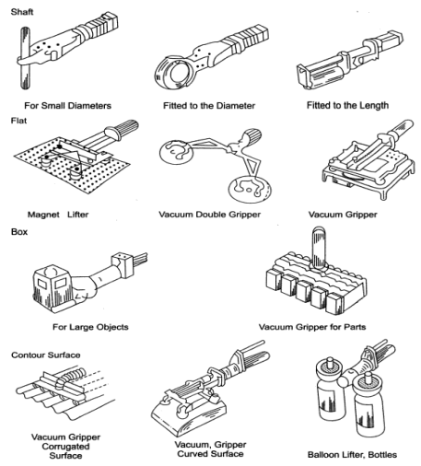
Fig. 1.21 Robot end-effectors for different manufacturing applications

  - How many types of power drives are used in Robot?
- Robot Actuators
  - The robot arm can be put to a desired motion with its payload if actuator modules are fitted in to provide power drives to the systems.
  - There are three different types of power drives in common use.
  - They are
  - Pneumatic
  - Hydraulic
  - Electric

  - Draw and describe the pneumatic power drive.
- Pneumatic Power Drives
    - Pneumatic system may employ a linear actuator, i.e. double acting cushioned cylinders or it may employ rotary actuators like vane motors.
    - However, linear actuators are more popular.
    - Pneumatic power drive systems use compressed air to move the robot arm.
    - Air is compressed by an air compressor and the compressed air is directed through filter, regulator and lubricator (FRL) units to the hose pipes and then to the pneumatic cylinders through the direction control valve.
    - For stable supply, an air compressor usually pumps air into a storage tank and from there, it passes through FRL units to the pneumatic cylinder.
    - A scheme of a pneumatic power supply in a bang-bang (non-servo) robot is illustrated in Figure 1.22.

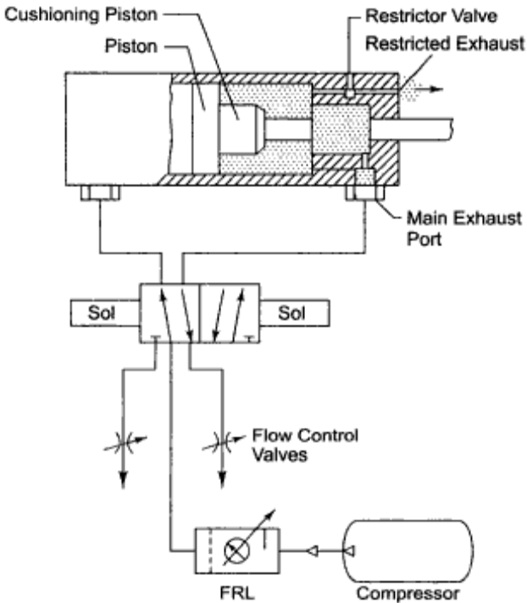
Fig. 1.22 Scheme of the pneumatic power supply

- As air enters into the cylinder via the directional control valve, the piston moves on its outward stroke and when air is diverted to enter into the other end of the cylinder, the piston make the return stroke.
- The return air is exhausted into the atmosphere.
- Pneumatic direction control valve can be operated by either levers, rollers or solenoids and this can also be pilot operated.
- Solenoid controlled valves are most common and they can be operated by micro switches which energize the solenoids.

- Repeatability Error and Robot Accuracy
  - Advantage
    - The advantage of using pneumatic actuators is their simple construction.
    - Non-servo robots can be built up with pneumatically powered actuators.

      - Disadvantages
        - The main disadvantage of a pneumatic system is the mass inertia and delayed response of the robot arm due to the sponginess and reduced repeatability.

          - Repeatability
- It may be mentioned that repeatability refers to the robot’s ability to return to the actual programmed point or a point in space that had previously been taught to the robot.
- Usually, the robot will not always return to the same programmed point, but will reach the point with some error known as repeatability error.
- Repeatability should not be confused with robot accuracy.

  - Accuracy
- The accuracy refers to the robot’s ability to achieve a given target position.
- A robot due to its limitations of control resolution may not be able to move to the target point, but is capable of moving to a programmed point very close to the target point.
- The difference between the positions of the target point and the programmed point is the accuracy error.

  - The repeatability error is a normal random variable and may be plus or minus a particular value centering around the programmed point.
- However, to have a good precision covering both the aspects of accuracy and repeatability for a pneumatically actuated robot, the control system becomes expensive and the main advantage of simplicity in construction is lost.
- Servo controlled pneumatic systems are quite expensive.

  - Draw and describe hydraulic power supply.
  - Hydraulic Systems
  - In a hydraulic system, the electric motor pumps fluid (oil) from a reserve tank to the hydraulic actuators which are, in general, double acting piston-cylinder assemblies.
  - Fluid at a higher pressure passes through control valves before its entry into the linear actuators.
  - On the other hand, rotary actuators comprising some motors or hydraulic motors which rotate continuously may also be employed.
  - Thus in a hydraulic system, both linear and rotational motions are possible.
  - Figure 1.23 indicates a schematic layout of a hydraulic power supply.

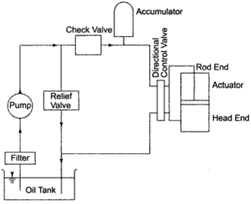
Fig. 1.23 Scheme of the hydraulic power supply

- Figure 1.24 indicates the hydraulic circuits used in arm extension or shoulder swiveling arrangement of a bang-bang robot.

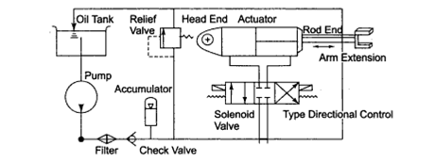
Fig. 1.24 Hydraulic circuit diagram for arm-extension of a non-servo robot

- Figure 1.25 illustrates the hydraulic circuit for waist movement achieved through a hydraulic motor.

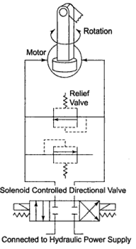
Fig. 1.25 Non-servo circuit for rotational movement

- Fluid is pumped from the tank and filtered.
- It then passes through a check valve, accumulator, solenoid controlled-spring centered-direction control valve to the cylinders used for extension of the arm, swing of the shoulder, or rotation of the waist.
- The circuit contains a pilot operated relief valve so that the fluid is returned to the tank.

- Filter
  - The filter separates out any foreign particles that may wear off the hydraulic system elements.
  - It also filters the dirt that may be present.
  - The accumulator helps the systems to send additional fluid to the cylinder if there is a sudden demand for the fluid and it also acts as a shock absorber.

- Relief Valve
- The pilot operated relief valve maintains the system pressure constant.
- When the system pressure increases, it allows the fluid to pass through the central bore of the spool to open a pilot spool and facilitates the fluid to return to the tank.
- It eliminates noise and vibration by streamlining the pulsations of the system pressure and holding the system pressure at the preset valve.

  - Check Valve
    - The check valve allows the hydraulic fluid to flow in only one direction and restrict the fluid to flow in the reverse direction.
    - The check valve also helps to maintain system pressure.

      - Direction Control Valve
    - The direction control valve allows the fluid to enter into the valve from the pump and then to either the rod end or the blind (head) end of the cylinder by moving the spool to the right or to the left.
    - The spool is pulled by a solenoid, the spool can be shifted.
    - Solenoid-operated direction control valve is used in non-servo or bang-bang type of robot.
- However, servo-controlled valves use jet pipes.
- A hydraulic power source is generally used for increase payload.
- It may be used in hazardous, volatile and explosive environments like a spray painting booth.
- However, maintenance of hydraulic systems to prevent leakage of oil is very important.
- The hydraulic fluid can be recycled.
- It can take heavy loads yet provide smooth operation.

  - How many types of controllers are used in robotics? Define each type.
- Robot Controllers

- The manipulator of a robot moves its arm, wrist and end-effector after it receives signal from the controller in the same way a man moves his arm or his body according to the signals sent by his brain.
- So, the controller acts as a brain of the robot.
- Control system in a robot may be two types
  - Open loop system and
  - Closed loop system.
- Control may again be grouped as
  - Non-servo system and
  - Servo system.

    - Open Loop System
- In the open loop control, drive signals are sent to the actuators and there is no feedback

    - Close Loop System
- In the open loop control, drive signals are sent to the actuators and there is feedback

    - Non-Servo System
- However, in non-servo control systems, drive signals are sent to the actuator via the solenoid valve, and as soon as the actuator drives the wrist or end-effector to the desired position, a signal through some limit switch is sent back indicating that the arm has reached the position.
- A non-servo, also called bang-bang controlled system is illustrated in Fig 1.26.

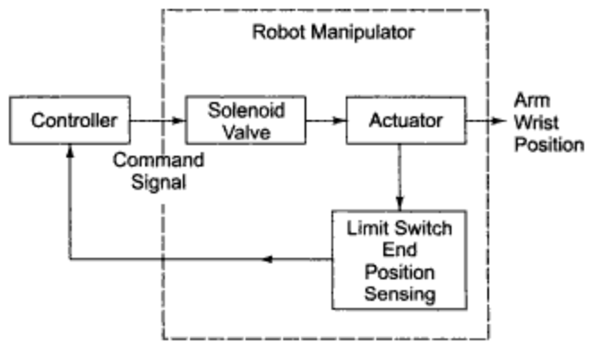
Fig. 1.26 The non-servo system

- When the manipulator arm reaches the ends of some intermediate stops, it touches a microswitch which sends signals to the controller informing it that the arm has reached the desired position.

- Servo System
- On the other hand, in the servo control drive, reference signals are sent to the actuator via the servo valve and the actuator moves its arm, wrist or finger to a current position and continuous measurement is taken to estimate the error between the desired position and the actual or current position.
- This error signal is fed back continuously to monitor the position and as soon as the error becomes zero, the desired location is achieved and the actuator stops moving.
- Figure 1.27 indicates a simple scheme of a positional servo.

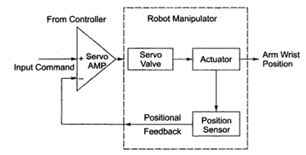
Fig. 1.27 Simple positional servo system

- Positional sensors are employed at the joints, wrist or suitable locations to feedback the positional information to the comparator.

  - What is the hierarchy of control for servo robots?
- The Hierarchy of Servo Robots
  - The controller may employ a processor which accomplishes the tasks by breaking them down into several subtasks for which a hierarchical level of control may be organized.
  - For example, a vision robot may use a high-level vision processor that provides a knowledge of position as a component identity including its position, and orientation and avoidance of obstacles; the robot controller through its other sensory devices feeds back the data to accomplish the tasks at various levels including the movement of joints or axes of the robot.
  - Thus a complex task may be divided into simple tasks.
  - A simple task, say ‘load’ may be broken down to elemental moves, say ‘move’ and ‘grasp’, and the elemental moves may further be decomposed into action commands in X, Y, Z primitives of trajectory in the world coordinates.
  - The world coordinates commands are then transformed into joint actuator commands, 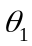,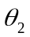,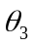, … through transformation coordinates and finally the drives signals are sent through positional and velocity servo of various joint axes of the robot.
  - A scheme of control hierarchy is illustrated in Figure 1.28.

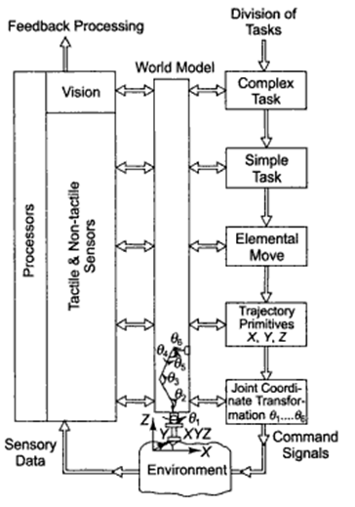
Fig. 1.28 The control hierarchy of a robot

  - Describe motion control of robot.
- Motion Control of Robots
  - The robot manipulator can move its arm, wrist or gripper to the desired position describing a definite path.
  - Programming for path generation can be accomplished in various ways and this path is controlled by the robot controller by the following methods:
1. Point-to-point control
2. Continuous path control

- Point-to-Point Robot
- In the point-to-point programming method, the robot arm can be taught to move from a point to another in its work envelope.
- The robot can be programmed through some joysticks or man-machine interface as done in the teleoperated robot, or through push buttons in the teach pendant box.
- In this way, an individual axis can be moved independently or more than one of its axes can also be moved at a time.
- Once the robot arm has been brought to a particular point, the locational point is recorded into the robot's memory in the controller by the programmer who pushes a button.
- Next the robot arm is moved and brought to a second point and this new point or position is recorded by pushing a `record' button.
- This method is known as teaching.
- Thus the point-to-point path generation in steps is done in the teach mode.
- In 'auto' mode, all the points so recorded are played back and the robot arm starting from the first point moves through the programmed points till it reaches the end point.
- The controller moves the manipulator back to the position of the first point and the entire path is repeated.
- However, in point-to-point control, the path generated between points, and (Fig. 1.29) cannot be predicted during programming as two sequential moves from the first point to the end point may describe different paths.
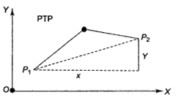
Fig. 1.29 Point-to-point motion control

- Figure 1.29 indicates a P-T-P controlled path.
- All the axes of the robot manipulators move at the maximum rate.
- In order to move from point P1 to P2, movement along the x-direction is greater than the movement along the y-direction.
- So the manipulator will complete the required vertical movement (y) long before the horizontal movement (x).
- All the axes move in an uncoordinated manner.
- However, the individual motions may be controlled and the velocity may be adjusted so that all the axes motions reach the end point simultaneously.
- A typical teach pendant is illustrated in Fig 1.30.

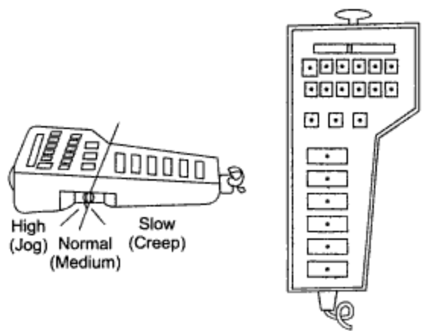
Figure 1.30 The teach pendant of a robot.

- Robot with Joint-Interpolated Motion
- In the joint-interpolated motion, different axes move at different velocities to reach the final position following a point to point generated path.
- In this method, the movement along the horizontal axis takes place at a higher velocity than the movement along the vertical axis as in case of Fig. 1.29 and both the axes reach the final position at the same instant.
- However, for a robot with multiple degrees of freedom, it is difficult to predict the path; nevertheless the joint-interpolated motion provides a smoother action compared to the simple P-T-P action.
- In the joint-interpolated motion, the axes move in a coordinated manner.

  - Robot with Controlled Path Motion
- In the point-to-point control, an exact path between the taught points cannot be predicted.
- In controlled path motion the discrete points programmed earlier describe a straight line between taught points as illustrated in Fig 1.31.

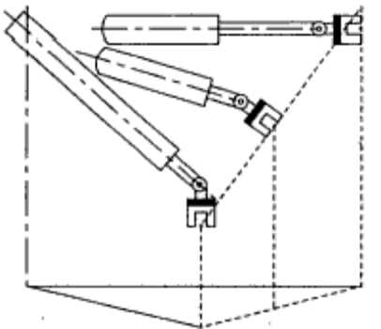
Fig. 1.31 Linearly interpolated controlled path motion

- The robot arm therefore moves in a straight line.
- However, the linearity of the straight line can be strictly maintained if larger numbers of points are programmed.
- The path generation involves computations for coordinate transformations between joint angles and the global coordinates.
- The intermediate points between two end points can be interpolated by computation in the global coordinates and the controller sends the command signals in joint coordinates.
- The solution for generating the straight line path is of course not unique as shown in Fig 1.32.
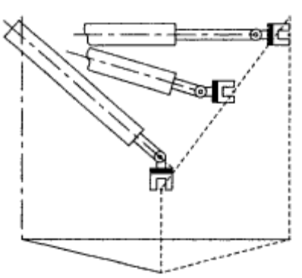
Fig. 1.32 Linearly interpolated move by a robot.

- Continuous Path Robot
- Continuous path motion is a coordinated motion.
- The robot arm, wrist or end-effector follows a specified path in a 3-D space.
- Continuous path motion is a coordinated point-to-point motion described very closely or continuously on a time base.
- In this programming method, the robot arm is led through the path describing several points at a fixed time or in discrete time intervals.
- The arm may be traversed very slowly following a point-to-point path at small intervals, or else the arm can be moved fast following wide apart points.
- Thus, several hundreds of individual points can be recorded in the controller's memory.
- The path of the robot may be any curve, or an arc of a circle.
- In specific cases, it may be a straight line.
- The recorded points along the curve may be stored in cassette tapes or floppy playback disks.
- When the program is on playback mode, the robot moves continuously through the stored points as illustrated in Fig.1.33.

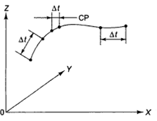
Fig. 1.33 The continuous path motion

  - How many types of controllers are used in robotics? Define each type.
- Types of Robot Controls
- There are different types of controllers used in robotics.
- They are:
- Drum controller,
- Air logic controller,
- Programmable controller,
- Microprocessor-based controller, and
- Minicomputer-based controller.

- Drum Controller
- In drum controller, as the drum rotates, it actuates those switches which are wired to hydraulic valves.
- Thus, the manipulator movements are controlled by the rotational advancement of the drum.
- It is now obsolete.

- Air Logic Controller
- Air logic controller employs a number of pneumatic valves which in turn control the opening and closing of the main valves of the robot manipulator in close synchronization with the timers.

- Programmable controller
  - In a programmable controller, the sequential order in which the switches are to be operated in kept in the memory.
  - It can be entered into the controller with the help of a keyboard.
  - The program can also be displayed on the CRT screen.
  - A programmable controller may be used to control and coordinate various tasks to be done by the peripheral equipment including robots.

- Microprocessor-based controller

      - The microprocessor-based control is the most popular robot control system.
      - Microcomputers of various types may be employed to program the sequential tasks or motions and store them in its memory.
      - It contains special circuitry to interpret the programs kept in its memory and at the same time it sends drive signals to various actuators of the robot manipulator.
      - It can also count the number of sequential events or tasks accomplished.
      - It is
        - versatile,
        - programmable and
        - has good memory.
      - Point-to-point, continuous path and controlled path motions can be easily programmed in microprocessor-based robotics systems.

- Minicomputer-based controller
  - Robots having higher payload are manipulated through a minicomputer-based controller.

  - Describe programming methods of a Robot.
- Programming Methods
- Programming of a robot can be done by several methods.
  - Lead through programming,
  - Teach pendent programming,
  - Textual programming using computer terminal.

    - Lead through programming
- In this method a robot is switched to ‘program’ mode when the operator holds the robot manipulator or its wrist and moves it through a desired path.
- The robot controller memorizes all the points so generated.
- During playback, the robot manipulator describes the same path as taught during learning.
- Moreover, editing facility can be provided to compensate for error.

- Some of the robots with continuous path control system use ‘teach arm’ or joystick.
- As the joystick is moved in different axes, the robot manipulator axes follow the motions exactly.
- Speed commands are provided to increase or decrease the speed of the manipulator.

- Teach pendent programming
    - Teach pendent is the most popular method of programming industrial robots.

- Textual programming using computer terminal
        - Microcomputers or minicomputers are used for programming industrial robots and different languages have been developed for both on-line and off-line monitoring.
        - Robot software languages include facilities such as
  - Subroutines,
  - Program branching,
  - Interruptions and signaling to peripheral equipment, etc.
        - Different languages for robot software system include
  - VAL used in Unimation robots,
  - SIGLA used in Sigma robots,
  - HELP used in Pragma assembly robots,
  - AUTOPASS in IBM robots and so on.

        - At present, there are many different robot programming languages with various important features like flexibility in
  - Editing,
  - Interpreting,
  - Compiling,
  - Simulating and debugging facilities.

  - What are the advantages and disadvantages of pneumatic power drive?
- Advantages
  - Pneumatic power drive is reliable,
  - It has simple construction,
  - It provides low-cost operation,
  - Non-servo robots can be built up with pneumatically powered drive actuator.

- Disadvantages
  - It includes mass inertia.
  - Delayed response of the robot arm due to the sponginess and reduced (low) repeatability.
  - Servo-controlled pneumatic systems are quite expensive.

  - What are the advantages and disadvantages of Hydraulic power drive?
- Advantages
  - The hydraulic fluid can be recycled.
  - It can take heavy loads yet provide smooth operation.
  - It provides greater power and higher torque.

- Disadvantage
      - Electro hydraulic valves are quite expensive in hydraulic system.

- Uses
          - It is generally used for increased payload.
          - It may be used in hazardous, volatile and explosive environment like a spray painting booth.

1.24 What are the advantages of hydraulic actuator system over Electrical motor?
- The advantages of hydraulic actuator systems over Electrical power as follows:
Hydraulic Power Drive | Electrical Power Drive
1. It can take heavy loads. | 1. It has relatively low payload.
2. It provides greater power and higher torque. | 2. It provides low power and torque.
3. Using Electro hydraulic valves are quite expensive. | 3. Using Electrical amplifier and other Electrical control circuit are less expensive.

Chapter 2
Robot Kinematics

2.1 Describe Robot Kinematics. Describe forward and inverse kinematics scheme.
- Robot Kinematics
  - Robot arm kinematics deals with the analytic study of the motion of a robot arm with respect to a fixed reference coordinate system as a function of time.
  - The mechanical manipulator can be modeled as an open loop articulated chain with several rigid links connected in series by either ‘revolute’ or prismatic’ joints driven by the actuators.

- Forward Kinematics problem
  - For a manipulator, if the position and orientation of the end-effector are derived from the given joint angles and link parameters, the scheme is called the forward kinematics problem.

- Reverse Kinematics problem
  - If the joint angles and the different configuration of the manipulator are derived from the position and orientation of the end-effector, the scheme is called the reverse kinematics problem.

    - Figure 2.1 illustrates the scheme of forward and reverse kinematics.

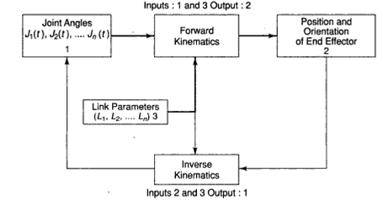
Fig. 2.1 Forward and inverse kinematics scheme

- Representing the Position
  - Considering the revolute type of joint only,
    - The position of the end-effector can be represented by the joint angles, 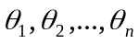 as,
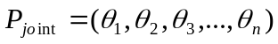
    - The position of the end-effector can also be defined in world space as,
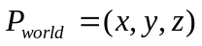
  - For a Revolute-Revolute(R-R) joint having 2 degrees of freedom, the schematic diagram of the links in 2-D, is shown in Figure 2.2, and are the links, and are the angles of rotation.

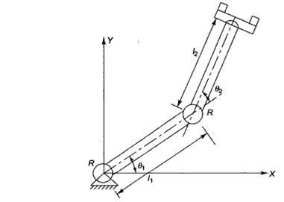
Fig. 2.2 R-R type DOF 2-D manipulator

2.2 Discuss Forward and Reverse kinematics of 3DOF Robot arm.
- Forward and Reverse Kinematics (Transformation) of Three Degree of Freedom Robot ARM
  - The position and orientation of the end-effector shown in Figure 2.3 in world space.
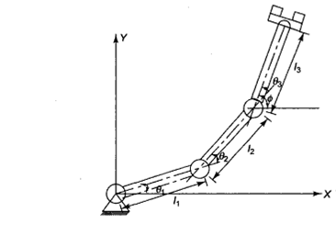
Fig. 2.3 Three DOF 2-D manipulator

- Forward Transformation
- The position of the end-effector shown in Figure 2.3 in world space can be determined from the joint angles and link parameters by the following equations,
- The orientation of the end-effector shown in Figure 2.3 in world space can be determined from the joint angles and link parameters by the following equations,
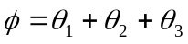

- Reverse Transformation
  - The joint angles can also be determined from the end-effector position 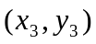 and the orientation position 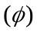, using reverse transformation in the following way
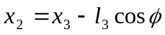
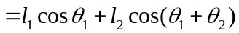
Now
(1)

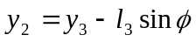
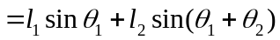
Now
(2)

Now
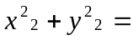
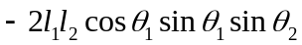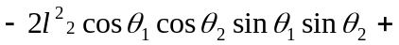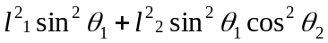
or, 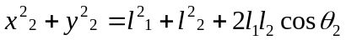
or, 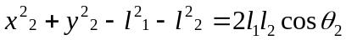
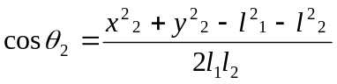

- Substituting the value of 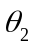in Equation (1) and (2), we obtain the value of .
- Finally, the value of 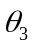can be obtained using the following relation,
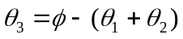

2.3 What is A matrix? Deduce 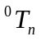 matrix for n-DOF manipulator.
- Kinematics Equations using Homogeneous Transformation
  - A manipulator can be described as a series of links connected at joints, the angles between the links being called the joint angles.

- A matrix.
      - The position and orientation of one link can related to the next link by a homogeneous transformation, known as the A matrix.
      - 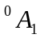relates the firs link to the manipulator base, 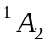relates the second link to the first link, and so on.

- matrix for n-DOF manipulator
          - Hence, for n-degrees of freedom manipulator, there are joint-link pairs with link attached to a supporting base, and link attached with a tool (end-effector).
          - Joint is thus the point of connection between link and link 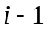 as shown in Figure 2.4.

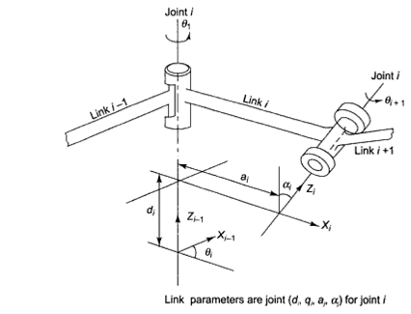
Fig. 2.4 Link coordinates system

          - A joint axis (for joint) is established at the connection of two links, which will have two normal connected to it, one for each of the links.
          - The relative positions of two such links (link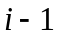 and link) is given by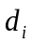, the distance measured along the joint axis between the normals.
          - The joint angle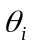between the normals is measured in a plane normal to the joint axis.
          - Thus, andare called the distance and the angle between the adjacent links respectively.
          - A link maintains a fixed configuration between its joints which can be characterized by two parameters, 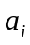 and 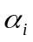,
Where
            - is the shortest distance measured along the common normal between the joint axes (i.e., the 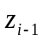 and 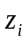axes for jointand joint respectively), and
            - is the angle between the joint axes measured in a plane perpendicular to .
          - Thus, and are called the length and the twist angle of the link , respectively,

- Four parameters, ,,and are thus associated with each link of a manipulator which come in pairs:
            - The link parameters 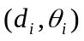determine the relative position of the neighboring links.
  - An orthogonal Cartesian coordinate system (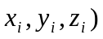can be established for each link at its joint axis.
  - When the joint axis is activated by the joint actuator, linkwill move with respect to link, and, since, the 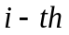 coordinate system is fixed in link, it moves together with link.
  - Finally, the 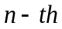 coordinate system moves with the hand (link).
  - The base coordinates are defined as the 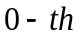 coordinate frame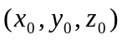.

    - For a six-axis PUMA-like robot arm, there are seven coordinate frames, name 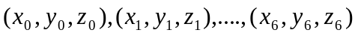where
      - 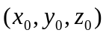is called the world coordinate system and
      - 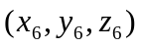is called the tool coordinate system.

    - Determining and Establishing Every Coordinate Frame
        - Every coordinate frame is determined and established based on the following rules:
          - Theaxis lies along the axis of motion of the joint.
          - The axis is normal to the axis and pointing away from it.
          - The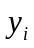axis is normal to, and.

- Develop a Homogeneous Transformation Matrix
  - Once the coordinate system has been established for each link, the next step is to develop a homogeneous transformation matrix relating thecoordinate frame to the 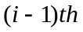coordinate frame by performing the following successive transformations:
              - Translate a distance along theaxis to coincide with the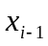 and.
              - Rotate an angle of about the axis to align the axis with the axis.
              - Translate a distance along the axis so that the two origins coincide.
              - Rotate an angle of about the axis to coincide with the two coordinate systems.
                - Each of the above operations can be expressed by a basic homogeneous rotation-translation matrix and the product of these four basic homogeneous transformation matrices yields a composite homogeneous transformation matrix, 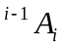for the adjacent coordinate framesand.
                - Thus
                - The homogeneous matrix which specifies the location of the coordinate frame with respect to the base coordinate system is the chain product of successful coordinate transformation matrices of.
                - Thus
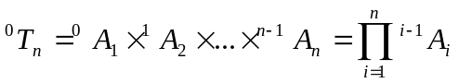
= 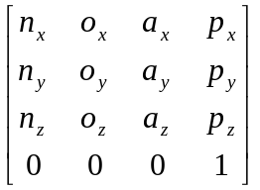

                - The four column vector of can be used to define the position and orientation of the end-effector.
                - The vector represents the position of the end-effector with respect to the base frame.
                - The three vectors, and, specify the orientation of the end-effector,
      - a is the approach vector,
      - o is the orientation vector and
      - is normal to o and a .
                - These three vectors together form a coordinate frame relative to the base frame.

Chapter 3
Robot Drives, Actuators and Control

  - What is the function of FRL unit?
- Pneumatic Conditioners
  - In pneumatic power drives, air is compressed by an air compressor and the compressed air is directed through filter, regulator and lubricator (FRL) units to the hose pipes and then to the pneumatic cylinders through the direction control valve.
  - The main function of pneumatic conditioners is to make the air acceptable.
  - The conditioners include air filters, regulators, and lubrications.

    - Air Filter
- An air-filter is required to remove dirt and other contaminants from the air.
- Airborne dirt and other contaminants damage cylinder walls, valves and other pneumatic elements in the circuit.
- The baffling system installed within the air filter separates the dirt particles from the air.

  - Regulator
    - Regulator is used to deliver air at a constant pressure to the pneumatic actuators.
    - The poppet can be opened or closed depending on the demand of load on the actuator.
    - Air entering the regulator passes through the orifice that can be provided by opening the poppet.

      - Lubricators
        - Lubrication is necessary for the internal moving parts of pneumatic components.
        - Oil reaches the drip tube by siphonic action.
        - When the air passes through the variable control orifice, oil delivered by the drip tube is mixed with air to form an oil-mist that contains coarse and fine particles.
        - The oil-mist is carried out and it lubricates the moving components of the pneumatic circuit.

  - What is an air compressor?
- Compressor
  - An air compressor is a machine to compress air from atmospheric pressure to a higher level of pressure at the expense of reduction of volume.
  - Compressors are of two types :
    - Positive displacement compressor and
    - Rotary vane or screw compressor.

  - What is the basic difference between a stepper motor and a dc motor?
- Stepper Motor
  - The stepper motor can be considered as a digital device which converts electrical pulses into proportionate mechanical movement.
  - Each revolution of the stepper motor's shaft is made up of a series of discrete individual steps.
  - Being bidirectional, it is ideally suited for a wide variety of control and positioning applications in the industrial world.
  - The stepper motors may be used in educational and hobby robots which can take lighter loads.

- Stepper Motor VS AC or DC Motor
  - Conventional ac and dc motors have a free turning shaft.
  - The stepper motor shaft rotation is incremental.
  - It is designed to rotate a specific number of degrees, (usually 7.5° or 15°) for each electrical pulse received by its control unit.
  - This increment is known as step angle.
- It is used in digital control systems where the motor receives open loop commands as a train of pulses to turn a shaft or move a plate by a specific distance.
- The basic feature of a stepper motor is that upon being energized it will move and come to rest after some number of steps in strict accordance with the digital input commands provided.
- The repeatability (the ability to position through the same pattern of movements a number of times) is very good.
- With a stepper motor, a position sensor or feedback system is not normally required to make the output member follow the input instructions.

  - Draw the cross-section and describe the differential operation of a stepper motor.
- Principle of Operation
  - A stepper motor’s operation is based on the basic magnetic principle: like magnetic poles repeal and unlike poles attract.
  - A simplified representation of a stepper motor is shown in Figure 3.1(a).
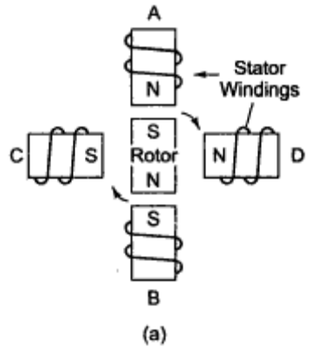
Fig. 3.1(a) Stepper motor rotation

  - If the stator windings are energized so that the stators A and D are north poles and the permanent magnet rotor positioned as shown in Figure (a) a torque will be developed to position the rotor as shown in Figure 3.1(b) with the rotor aligning itself between the ‘average’ South Pole and the ‘average’ North Pole.

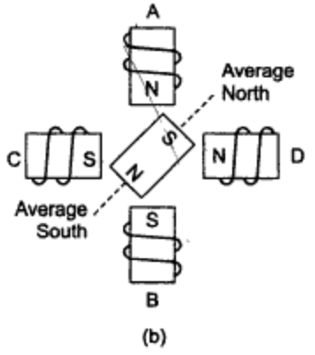
Fig. 3.1(b) Stepper motor rotation

  - As indicated in the Figure, the rotor’s direction of rotation would be clockwise.
  - Reversing the polarity of the pair of poles AB draws the rotor 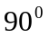clockwise to its new position of Figure 3.1( c ).
  - This is known as full step.
  - If poles AB had been turned off, instead of being reversed, the rotor would rotate 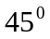clockwise to line with the field of the pair of poles CD, as shown in Figure 3.1(d).

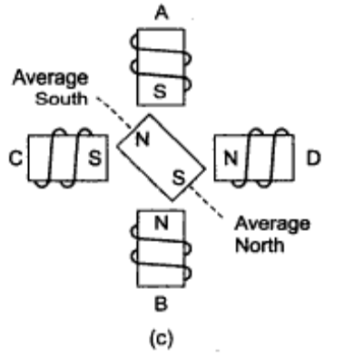
Fig. 3.1(c) Stepper motor rotation

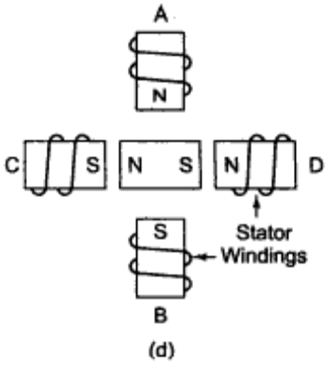
Fig. 3.1(d) Stepper motor rotation

  - This is known as half step.
  - So, if the windings are excited in a particular sequence, the stepper motor of Figure 3.1would have either four steps per revolution (with step angle) or eight steps per revolution (withstep angle).

    - In the first case, two pairs of poles have to be energized at all time, and their polarities reversed one by one.
      - In the second case, either one of two pairs of poles are energized at a time in a proper sequence with their polarities reversed as above.
      - In the half step sequence, the rotor moves half its normal distance per step.
      - If the stator windings are excited in the reverse sequence, the direction of rotation would be counterclockwise.

- Stepper Motor using Differential Construction
          - The simple stepper motor shown in the Figure would have only four full steps or eight half steps per revolution.
          - Actual stepper motors obtain small angle increments by using large number of poles (using a differential construction).
          - One such stepper motor using differential construction is shown in Figure 3.2.

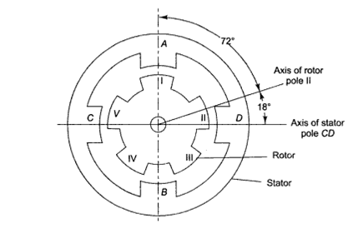
Fig. 3.2 Cross-section of stepper motor for differential operation

          - The stator has a 2 phase winding while the rotor has five projecting poles.
          - The position shown is for poles AB energized with pole A as North Pole, where 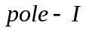 is aligned with AB axis.
          - If only the pair of poles CD is energized, the rotor will rotate by 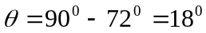to align 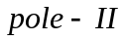with CD axis.
          - There are many stable positions for any given stator energization pattern.
          - Proper selection of the energizing sequence of the stator windings allows the stable positions to be made to rotate smoothly around the stator poles, establishing the rotational speed and the direction of the rotor.

Chapter 4
Robot End-Effectors

4.1 Define and classify robot end effectors.
- Robot End-Effectors
- Robot end-effector is the gripper or end-of-arm tooling mounted on the wrist of the robot manipulator arm.
- A robot performs a variety of tasks for which various tooling and special grippers are required to be designed.
- A robot manipulator is flexible and adaptable, but its end-effector is task-specific.
  - A gripper designed for picking up a tool to be fitted to a CNC machine tool is not suitable for welding a railway wagon.
A robotic end-effector which is attached to the wrist of the robot arm is a device that enables the general-purpose robot to grip materials, parts and tools to perform a specific task.
- The end-effectors are also called the grippers.
- There are various types of end-effectors to perform the different work functions.
- The various types of grippers can be divided into the following major categories:
  - Mechanical grippers,
  - Hooking or lifting grippers,
  - Grippers for scooping or lading powders or molten metals or plastics,
  - Vacuum cups,
  - Magnetic grippers,
  - Other: Adhesive or electrostatic grippers.

    - The grippers may be classified into:
  - Part handling grippers,
  - Tools handling grippes and
  - Special grippers.

- Part Handling Grippers
    - The part handling grippers are used to grasp and hold objects that are required to be transported from one point to another or placed for some assembly operations.
    - The part handling applications include
  - Machine loading and unloading,
  - Picking parts from a conveyor and moving parts, etc.

- Tools Handling Grippes
- There are grippers to hold tools like welding gun or spray painting gun to perform a specific task.
- The robot hand may hold a deburring tool.

- Special grippers
- The gripers of the robot may be specialized devices like Remote Centre Compliance (RCC) to insert an external mating component into an internal member, viz. inserting a plug into a hole.

The other types of end-effectors employ some physical principle like magnetism or vacuum technology to hold the object securely.

- Classification of End-Effector

  - An end-effector of a robot can be designed to have several fingers, joints and degrees of freedom.
  - Any combination of these factors gives different grasping modalities to the end-effector.
  - The general end-effectors can be grouped according to the type of grasping modality as follows:
  - Mechanical fingers,
  - Special tools,
  - Universal fingers.

- Mechanical fingers
  - Mechanical fingers are used to perform some special tasks.
  - Gripping by mechanical type fingers is less versatile and less dexterous than holding by universal fingers as the grippers with mechanical fingers have fewer numbers of joints and lesser flexibility.
  - However, they economize the device cost.
  - The grippers can be subgrouped according to finger classifications, for example, the number of fingers, typically two-, three-, and five-finger types.
  - The two-finger gripper is the most popular.
  - Another classification is according the single gripper and multiple grippers mounted on the wrist.
  - Robot end-effectors can be classified on the basis of the mode of gripping as external and internal gripping.
  - The internal gripping system grips the internal surface of objects with open fingers whereas the external gripper grips the exterior surface of objects with closed fingers.
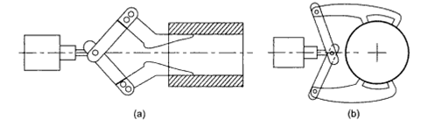
Fig. 4.1 Internal and external grippers (a) Internal gripper, (b) External gripper
  - Robot end-effector are also classified according to the number of degrees of freedom (DOF) incorporated in the gripper structures.
  - Typical mechanical grippers belong to the class of 1 DOF.
  - A few grippers can be found with more than two DOFs.
  - Universal fingers usually comprise multipurpose grippers of more than three fingers and or more than one joint on each finger which provide the capacity to perform a wide variety of grasping and manipulating assignments.

4.2 Describe the drive-system for Grippers with diagram.
- Drive System for Grippers
- In typical robot gripper systems, there are three kinds of drive methods:
      - Electric,
      - Pneumatic,
      - Hydraulic.

- Electric Drive System
- In electric drive system, there are typically two kinds of actuators,
            - dc motors and
            - stepper motors.
- In general, each motor requires appropriate reduction gear system to provide proper output force or torque.
- In the electric system, a servo power amplifier is also needed to provide a complete actuation system.

- Pneumatic Drive System
  - The pneumatic system has the merit of being less expensive than other methods, which is the main reason for it being used in most of the industrial robots.
  - Another advantage of the pneumatic system is the low-degree of stiffness of the air-drive system.
  - This feature of the pneumatic system can be used effectively to achieve compliant grasping which is necessary for one of the most important functions of grippers; to grasp objects with delicate surfaces carefully.
  - On the other hand, the relatively limited stiffness the system makes precise control difficult.

- Hydraulic Drive System
      - Hydraulic rives used in robot gripping systems are usually electrohydraulic drive systems.
      - They have almost the same configuration as pneumatic systems, though their features are different from each other.
      - A typical hydraulic drive system consists of
        - actuators,
        - control valves and
        - power units.
      - There are three kinds of actuators in the system :
        - Piston cylinder,
        - Swing motor, and
        - Hydraulic motor.

Chapter 5
Sensor and Intelligent Robot

5.1 Define sensors. Give examples.
- Robot Sensors
- Sensor
- A sensor is a transducer used to make a measurement of a physical variable.
- Any sensor requires calibration in order to be useful as a measuring device.
- Calibration is the procedure by which the relationship between the measured variable and the converted output signal is established.
- Care should be taken in the choice of sensory devices for particular tasks.
- The operating characteristics of each device should be closely matched to the task for which it is being utilized.
- Different sensors can be used in different ways to sense the same conditions and the same sensors can be used in different ways to sense different conditions.
- In order to function effectively, a robot has to receive information form the environment for necessary manipulation, send signals to various joints for necessary movement and interact with the peripheral equipment.

- For example
  - For example, when a robot picks up an object and places it in a definite location, it has to initially to get information about the presence of the object.
  - As soon as it understands that the object is present, the arm approaches it with a controlled speed and acceleration.
  - While approaching, it must avoid collision with any other obstacle.
  - It may also attempt to find the shape and orientation of the object to be grasped.
  - When the robot grips the object, it must identify the points where it should grip the object with specified force.
  - The object should not be pressed hard or deformed, or slip.
  - Sometimes it is necessary to have prior knowledge about the shape of the object before it is gripped.
  - Therefore, it is required to sense and measure all the important geometrical parameters of the object lying in an environment.
Searching, recognizing, grasping and placing the object are, therefore, some of the important steps to be done by a robot in a pick and place operation for which various sensors-both internal and external-are incorporated. However, the signals or sensory data obtained through the sensors must be processed, interpreted and integrated properly in a robot controller so that the robot can effectively and reliably perform the task.

5.2 Briefly describe different types of sensors used in robotics.
- Types of Sensor
  - There are two basic types of sensors.
  - They are
- Tactile and
- Non-tactile.

- Tactile Sensor
    - Tactile sensors are contact sensors that must be brought in contact with the object to obtain signals to measure the necessary quantities.
    - When tactile sensors make physical contact with the object, an electrical analog or digital signal is generated and sent to the robot controller.
    - Electrical signals may be obtained through the contacts of micro-switches.
    - Signal may also be obtained through mechanical pressures which change resistances of electrical strain gauges or generate electrical potentials in piezoelectric crystals.
    - Contact sensors can be subdivided into two principal categories:
- Binary or touch sensor and
- Analog or force sensors.

  - Binary Sensors
- Binary sensors, also called touch sensors, are basically switches that respond to the presence or absence of an object.
- These sensors provide a binary output signal which indicates whether or not contact has been made with the object.

  - Analog Sensors
- Analog sensors, also called force sensors, on the other hand provide an output signal proportional to a local force.
- They indicate not only that contact has been made with the object, but also the magnitude of the contact force between them.
    - Typical contact type robotic sensors include
      - Force sensors
      - Torque sensors,
      - Touch sensors,
      - Position sensors

        - Force and Torque Sensor
          - The capacity to measure forces permits the robot to perform a number of tasks like
      - Grasping parts of different sizes in material handling,
      - Machine loading and assembly work applying the appropriate level of force for the given part.
          - Force being a vector quantity must be specified both in magnitude and direction.
          - Force sensing in robotics can be accomplished in several ways.
      - A commonly used technique is wrist sensing, in which the sensors are mounted between the tip of a robot arm and the end-effector.
      - Another technique is joint sensing, in which the sensors measure the Cartesian components of force and torque acting on a robot joint and adds them vectorially.
        - For joints driven by dc motor, sensing is done simply by measuring the armature current for each of the joint motors.
      - Finally, a third technique is to form an array of force sensing elements so that the shape and other information about the contact surface can be determined.

- Touch sensors
          - Touch sensors are used to indicate that contact has been made between two objects without regard to the magnitude of the contacting force.
          - Included within this category are simple devices such as limit switches, micro-switches, etc.
          - In the simplest arrangement, a switch is placed on the inner surface of each finger of a manipulator hand as illustrated in Figure 5.1.

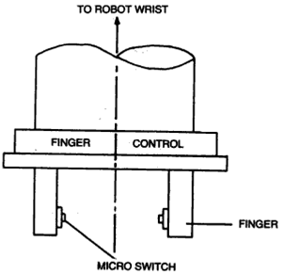
Fig. 5.1 Robot hand with microswitches

          - Multiple binary touch sensors can be used on the inside or outside surface of each finger to provide further tactile information.

- Non-tactile Sensor
    - Tactile sensors are contactless sensors which sense the signals remotely, but only within the specified range of distance from the object.
    - Non-tactile sensors detect and measure
      - Magnetic fields,
      - Infrared and ultraviolet light,
      - X-rays,
      - Ultrasonic sound waves or electromagnetic waves.
    - Typical non-contact sensors include
- Electro-optical imaging sensors,
- Proximity sensors,
- Range imaging sensors

- Range imaging sensors
    - Bats use range sensor for the purpose of navigation.
    - A typical range imaging sensor uses a laser scanner which is classified into two basic schemes: One based on transmitting a laser pulse and measuring the time of arrival of the reflected signal and the other based on transmitting an amplitude modulated laser beam and measuring the phase shift of the reflected signal.
    - The transmitted beam and the received light are essentially coaxial.
    - The principle of range sensor is shown in Figure 5.2.

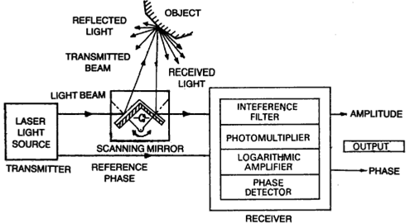
Fig. 5.2 Range imaging sensor

5.3 Define sensor. Describe five important characteristics of a sensing device.
- Sensory Devices
  - A sensor is a transducer used to make a measurement of a physical variable.
  - Any sensor requires calibration in order to be useful as a measuring device.
  - Calibration is the procedure by which the relationship between the measured variable and the converted output signal is established.
  - Care should be taken in the choice of sensory devices for particular tasks.
  - The operating characteristics of each device should be closely matched to the task for which it is being utilized.
  - Different sensors can be used in different ways to sense the same conditions and the same sensors can be used in different ways to sense different conditions.
    - Five important characteristics of any sensing device are:
      - Range,
      - Response,
      - Accuracy,
      - Sensitivity, and
      - Linearity.

        - Range
- This refers to the minimum and maximum change in input signal to which the sensor can respond.
- The sensor should possess a wide operating range.

  - Response
    - The sensor should be capable of responding to changes in the sensed variable in minimum time.
    - Ideally, the response should be instantaneous.

      - Accuracy
        - The accuracy of the measurement should be as high as possible.
        - The output of the sensing device should properly reflect the input quantity being measured or sensed.

          - Sensitivity
            - It refers to the change in the output exhibited by the sensor for a unit change in input.
            - The sensitivity should be as high as possible.
              - Linearity
                - The sensory device should exhibit the same sensitivity over its entire operating range.

- The following are the other considerations.
- The device should not disturb or have any effect upon the quantity it senses or measures.
- The device should be suitable for the environment in which it is to be employed.
- Ideally, the device should include isolation from receiving excess signals or electrical noise that could give rise to the possibility of misoperation or damage of the sensor, circuit or system.
- Also important are the physical size, cost and ease of operation.

5.4 Discuss position and displacement sensors.
- Position and Displacement Sensors
  - Position and displacement sensors are used as components of the robot control system.
  - The control structure of a robot needs to know the position of each joint in order to calculate the position of the end-effector thus enabling the successful completion of the programmed task.
  - The movements of the joints can be either linear or angular (rotary) depending on the type of robot.
  - Future developments in the robotics field may allow the use of external sensors to actually measure the end-effector position in relation to its surroundings, thereby dispensing with the need to calculate it from the joint positions.
  - But, for the present, internal position sensors remain the most accurate and reliable way of determining the end-effector position within a robot control structure.
  - There are two main types of position sensors: absolute and incremental, the latter being also called displacement sensors.
  - Some common devices which are used as position sensors are:
  - Potentiometers,
  - Encoder,
  - LVDT.

- Potentiometers
  - Potentiometers are analog devices whose output voltage is proportional to the position of a wiper.
  - Potentiometers may be either linear or angular.
  - Figure 5.3 illustrates a typical angular potentiometer, which has
- a resistive element and
- a rotating wiper.

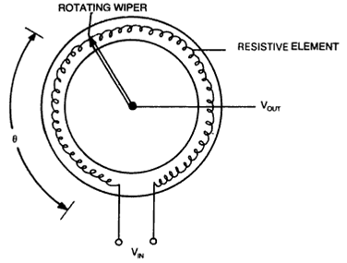
Fig. 5.3 A potentiometer

  - When voltage is applied across the resistive element, the output voltage between the wiper and the ground is proportional to the ratio of the resistance on one side of the wiper to the total resistance of the resistive element, which essentially gives the position of the wiper.
  - The function of a potentiometer can be represented by the function,
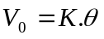
Where 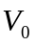= Output voltage, = Voltage constant of the potentiometer in volts per radian (for angular pot) or volts per mm (for linear pot) , =Position of the pot in radian or mm.
  - Potentiometers are relatively inexpensive and easy to apply.
  - However, they are temperature sensitive, a characteristic that also affects their accuracy.
  - The wiper contact is another limiting factor, being subject to wear and producing electrical noise.

- Encoders
      - Encoders which are non-contact type position sensors are classified into two basic types:
        - Incremental and
        - Absolute.
      - Unlike potentiometers which give analog signals, encoders give digital signals directly.

- Incremental Encoder
      - In a simple incremental encoder, a disc is encoded with alternating transparent and opaque (light and dark) stripes aligned radically;
        - A photo transmitter (light source) is located on one side and
        - A photo receiver (photo cell) on the side of the disc.

      - As the disc rotates, the light beam from the transmitter is alternately passed and broken which is detected by the receiver, whose output is a pulse train having frequency proportional to the speed of rotation of the disc.
      - There are usually two sets of photo transmitters and receivers aligned out of phase to provide direction information.
      - By counting the number of pulses and by adding or subtracting based on the direction, it is possible to use the encoder for position information with respect to a known starting position.

- Absolute Encoder
  - Absolute encoders with which position can be known in absolute terms (i.e., not with respect to a starting position) employ the same basic construction as incremental encoders except that there are more tracks of stripes and a corresponding number of transmitters and receivers.
  - The stripes are usually aligned to provide a binary number proportional to the shaft angle and the angle can be read directly from the encoder without any counting.
  - The resolution of an absolute encoder depends on the number of tracks () and is given by
Resolution = 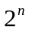

5.5 What is LVDT? Draw and discuss.
- LVDT (Linear Variable Differential Transformer)
  - The linear variable differential transformer (LVDT) is another type of position sensor, whose construction is shown in Figure 5.4.

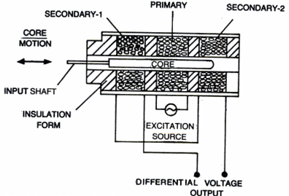
Fig. 5.4 LVDT construction

  - It consists of
  - A primary core,
  - Two secondaries core, and
  - A moveable core.
  - The primary is excited with an as source.
  - When the core is in its exact central location, the amplitude of the voltage induced in secondary-1 will be the same as that in secondary-2.
  - The secondaries are connected to cancel phase, and the output voltage will be zero at this point.
  - Figure 5.5 illustrates the nature of output voltage as the core is moved to the left or to the right.

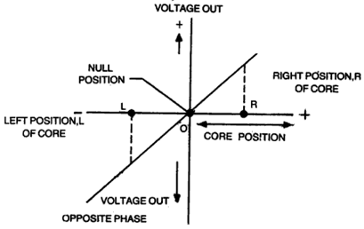
Fig. 5.6 LVDT output voltage versus core position
  - The magnitude of the output voltage is shown to be a linear function of core position, and the phase is determined by the side of the null position on which the core is located.
  - Finally, the ac output of LVDT can be converted to dc using rectifiers.

  - What is Artificial skin? How it works?
- Artificial Skin
  - The tactile array can be made of artificial skin.
  - Various plastic materials and synthetic rubber are used to produce materials with elastic properties, which are called elastomers, and can be used to make skin for a robot gripper.
  - Conductive elastomers can provide feedback signals which are proportional to the acting forces.
  - This device which is often called artificial skin is typically composed of an array of elastomers pads as shown in Figure 5.7(a).

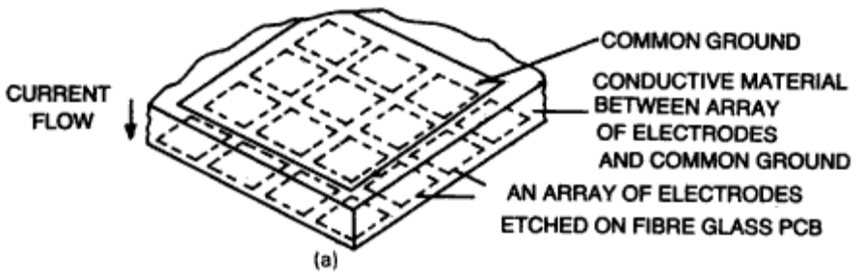
Fig. 5.7(a) Artificial skins

  - As each pad is squeezed by any object pressing against the surface, its electrical resistance changes in response to the amount of deflection in the pad, which is proportional to the applied force.
  - By measuring the resistance of each pad, which is easily transformed into electrical signals, information about the shape of the object pressing against the array as sensing elements can be determined.
  - As the number of pads in the array is increased, the resolution to the information obtained improves.
  - Figure 5.7(b) indicates two perpendicularly intersecting electrodes with conducting material in between.

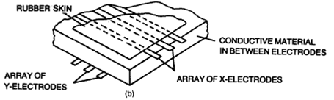
Fig. 5.7(b) Artificial skins

  - Change of resistance due to pressure causes electrical current of flow.

5.7 Define range and proximity sensor.
- Proximity and Range Sensors
  - The presence of an object can be sensed by a proximity sensor.
  - Photoelectric proximity sensors may control the motion of a manipulator arm.
  - Range sensors are used to sense and measure the distance between the objects and the sensing device and they may be used even to locate the workpiece in the robot workcell.
  - Proximity and range sensors may be located on the end-effector or wrist.

    - There are various techniques that may be employed designing proximity sensors.
  - They include
- Optical devices,
- Acoustics,
- Eddy currents,
- Magnetic fields etc.
  - A photoelectric proximity sensor that senses the presence of an object without making physical contact is indicated in Figure 5.8.

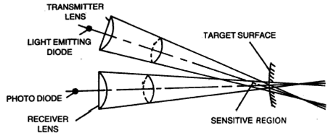
Fig. 5.8 Proximity sensor

  - It consists of a solid state LED which acts a transmitter of infrared light and a solid state photodiode which acts as a receiver.
  - Both are mounted in a small package.
  - The sensing space is approximately the intersection of two cones in front of the sensor.
  - If the reflectance and incident angle are fixed, the distance may be measured with suitable calibration.
  - When the received light exceeds a threshold valve, it corresponds to a predetermined distance.
  - Figure 5.9 indicates a proximity sensor that locates a part.

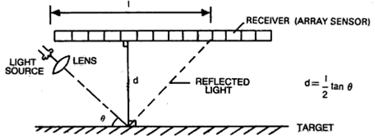
Fig. 5.9 Proximity array sensor

  - The distance between the target and the array of light sensors is given by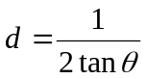.
  - The surface of the target is parallel to the sensing array.

Proximity sensors based on electrical fields are commercially available.
  - The sensing device when brought near the object creates an alternating magnetic field in a small region and this field induces eddy current through the conducting object.
  - The eddy currents produce their own magnetic field which interacts with the primary field.
  - This changes the flux density and indicates the presence of the object.

  - Proximity sensor using magnetic field is composed of a reed switch and a permanent magnet.
  - The sensor when brought near the target object activates the reed switch as the magnetic circuit is completed between the object and the sensor.

5.8 Describe various types of Electro-optical imaging sensors.
- Electro Optical Imaging Sensors
  - Electro optical imaging sensors use solid state cameras interfaced with a vision processor.
  - The cameras scan a scene, measure the reflected light intensities within a raster of say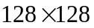pixels, convert these intensity values to analog and then binary electrical signals and feed the stream of information serially into the processor.
  - The signals are stored in the computer’s memory and processed in real time with consequent reduction of memory requirements.
  - Figure 5.10 indicates a connecting rod that moves past the viewing station and the camera can be triggered from the position sensor (incremental encoder) coupled to the moving conveyor belt.
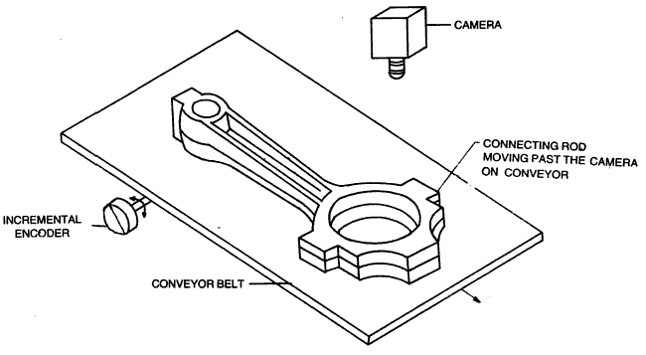
Fig. 5.10 The connecting rod moving on a conveyor belt

  - The other type of conveyor tracking sensor may also be used.
  - A robot works intelligently with the sensors and a good computer network.
  - An intelligent robot can sense, effect, interpret, generate and reason to arrive at a logical decision.
  - Unfortunately we are not in a position to understand the fundamentals of many intelligent functions that a man or even an animal has.
  - The other important issue is economy.
  - One has yet to learn to make sensible use of AI and Robotics.
  - However, the challenge is still there, to understand the fundamentals, and design an intelligent and smart robotics system.

5.9 Write short note on acoustic sensor.
- Acoustic Sensor
  - Acoustic sensors can also recognize the workpieces like an optical system.
  - A system for acoustic object recognition is shown in Figure 5.11.
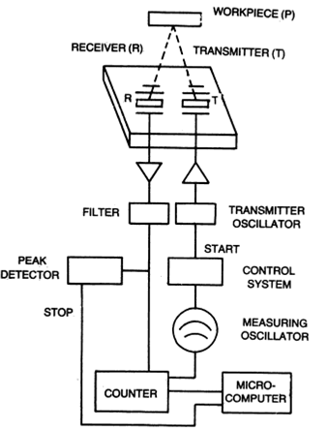
Fig. 5.11 Acoustic transducer for object recognition

  - A distance picture can be constructed from the transit time between the transmitted sound and received sound.

5.10 Describe Robot vision. Describe three functions of its operation.
- Robot Vision Systems
- Robot vision, also termed computer vision or machine vision, is an important sensor technology with potential applications in many industrial operations.
- Many of the current applications of machine vision are in inspection.
- However, it is anticipated that this will play an increasingly significant role in the future of robotics.
- While proximity, touch and force-sensing play a significant role in the improvement of robot performance, vision is recognized as the most powerful of robot sensory capabilities, and sensors, concepts and processing hardware associated with robot vision are considerably more complex that those associated with the sensory approaches discussed earlier.
- Though computer vision is a multidisciplinary field, it is still in its early stages of development.

  - Robot Vision
    - May be defined as the process of extracting, characterizing and interpreting information from images of a three-dimensional world.
    - The operation consists of three functions, broadly:
      - Sensing and digitizing,
      - Image processing and analysis,
      - Application

  - Sensing and digitizing
- It is the process that yields a visual image of sufficient contrast that is typically digitized and stored in the computer memory.

  - Image processing and analysis
- The digitized image is subjected to image processing and analysis for data reduction and interpretation of the image.
- It may be further subdivided into:
      - Preprocessing,
      - Segmentation,
      - Description,
      - Recognition,
      - Interpretation.
- Preprocessing deals with techniques like noise reduction and enhancement details.
- Segmentation partitions an image into objects of interest.
- Description computes various features like size, shape, etc. suitable for differentiating one object from another.
- Recognition identifies the object
- And finally interpretation assigns meaning to an ensemble of recognized objects in the scene.

  - Application
- The current applications of robot vision include
  - Inspection,
  - Part identification,
  - Location and orientation.
- Research is ongoing in advanced application in complex inspection, guidance and navigation.
The relationships between the three functions are illustrated in Figure 5.12.

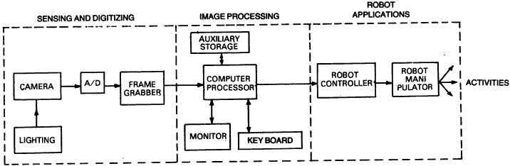
Fig. 5.12 Machine vision system functions

- The various areas of vision processing are grouped according to the sophistication involve in their implementation; such as

  - Low level vision,
  - Medium level vision,
  - High level vision.

    - Low level vision
      - The low-level vision refers to processes that are primitive in the sense that they require no intelligence on the part of the vision system.
      - Sensing and processing will be treated as low level vision functions.

- Medium level vision
  - Medium level vision refers to processes involving extraction, characterization and labeling components in an image resulting from low level vision.
  - Segmentation, description, and recognition of individual objects are treated as medium level vision functions.

    - High level vision
- Finally, high level vision refers to the processes that attempt to emulate cognition.
- Interpretation will be treated as high level vision processing.

5.11 List the operation under lower and higher vision.
- Low Level Vision
  - Sensing and Digitizing
  - Vision Camera and CCD Line Scan Sensor
  - Illumination Techniques
  - Analog-to-Digital (A/D) Signal Conversion
  - Image Storage
  - Preprocessing
  - Noise Reduction or Smoothing
  - Enhancement

- Higher Level Vision
  - Segmentation
  - Thresholding
  - Region Growing
  - Edge Detection
  - Object Description
  - Object Recognition
  - Interpretation

5.12 What is a high level vision?
- High Level Vision
  - High level vision refers to the processes that attempt to emulate cognition.
  - Interpretation will be treated as high level vision processing.
  - The material is subdivided into four principal areas:
- Segmentation,
- Object description or feature extraction,
- Object recognition and
- Finally the interpretation of visual information.
  - The operation under higher vision are:
- Segmentation
- Thresholding
- Region Growing
- Edge Detection
- Object Description
- Object Recognition
- Interpretation

5.13 Distinguish between low level and high level vision.
- Low level vision
  - The low-level vision refers to processes that are primitive in the sense that they require no intelligence on the part of the vision system.
  - Sensing and processing will be treated as low level vision functions.

- High level vision
      - Finally, high level vision refers to the processes that attempt to emulate cognition.
      - Interpretation will be treated as high level vision processing.

Chapter 6
Robot Language and Programming

6.1 Describe various Robot Programming languages. Mention their developers and their relative merits and demerits.
- Robot Languages
  - Robot languages have been developed for ease of control of motions of robots having different structures and geometrical capabilities.
  - Some of the robot languages have been developed by modifying the existing general purpose computer languages and some of them are written in a completely new style.
  - Some of the programming languages are:
    - WAVE,
    - AL,
    - VAL,
    - AML,
    - MCL,
    - RAIL,
    - HELP,
    - RPL,
    - PAL and
    - ADA.

- WAVE
  - WAVE, developed at Stanford, demonstrated a robot hand-eye coordination while it was implemented in a machine vision system.

    - Developers

      - WAVE was developed at Stanford.

        - Merits
          - WAVE incorporated many important features.
          - Trajectory calculations through coordination of joint movements, end-effector positions and touch sensing were some of the new features of WAVE.

            - Demerits
              - But the algorithm was too complex and not user-friendly.
              - They could not be run in real-time and on-line.

            - Application Area
              - It was implemented in a machine vision system.

- AL
  - AL is a more powerful language and was developed to control robot arms.
  - It has a source language, a translator to generate runnable code and a run time system for affecting various motions of the robot manipulator.
  - The syntax of the language can implement various subroutines, involving activities between the robot and its surroundings, various statements concerning SIGNALS and WAIT to carry on tasks in sequence.
  - Different sensors can be incorporated and programming can take care of some condition monitoring statements.
  - The robot manipulator movement-commands include various motions, velocities, forces, torques, etc. POINTY is another interactive system and a part of AL System.

    - Developers

      - AL developed at Stanford.

        - Merits
          - Trajectory calculations are possible at compile time and they can be modified during run-time.
          - AL has the capability of controlling multiple arms.
          - AL is very suitable for assembly tasks wherein many sensors are employed.
          - AL manipulates homogeneous matrix for control.

            - Application Area
- It was developed to control robot arms.

- VAL
  - VAL is an example of a first generation robot programming language.
  - VAL is a popular textual robot language developed by Unimation Inc. for the PUMA series of robots.
  - WAIT and SIGNAL commands can be given to implement a specific task.
  - The commands are subroutines written in BASIC and translated with the aid of an interpreter.

    - Developers
      - Developed by Unimation Inc.
      - Victor Sheinman developed VAL language.

        - Merits
          - VAL has been upgraded to VAL II system with more interlocking facilities.
          - VAL is very user-friendly.
          - It provides

    - Arm movement in joint,
    - World and tool coordinates,
    - Gripping and speed control.
          - Compiled BASIC has more flexibility.
          - VAL is a powerful language for many simple tasks.

            - Demerits
              - VAL does not have the same structured modular programming capability like AL, AML, JARS and ADA or VAL II.
              - VAL has not the capability of controlling multiple arms.

            - Application Area
- Developed for the PUMA series of robots.

- AML
  - AML is a second generation languages.
  - A manufacturing language, AML was developed by IBM.
  - The advantage of using AML is that integers, real numbers and strings can be specified in the same aggregate which is said to be an ordered set of constants or variables.
  - An aggregate can be used to specify coordinate values of the robot's joints or wrist position and orientation.

    - Developers
      - AML was developed by IBM.

        - Merits
          - AML is very useful for assembly operations as different user-robot programming interfaces are possible.
          - The programming language AML is also used in other automated manufacturing systems.
          - AML has the capability of controlling multiple arms.
          - AML is structured programming languages performing complex tasks.

            - Demerits
              - It is not much suitable for assembly tasks.
              - It is a low level intelligence.

            - Application Area
- AML is very useful for assembly operations as different user-robot programming interfaces are possible.
- The programming language AML is also used in other automated manufacturing systems.

- MCL
  - MCL is a second generation languages.
  - US Air force ICAM project led to the development of another manufacturing control language known as MCL by McDonnel-Douglas.
  - This is a modification of the popular APT (Automatically Programmed Tooling) language used in CNC machine tools as many similar commands are used to control machine tools in CAM applications.
  - Lines, circles, planes, cylinders and many other complex geometrical features can be defined in MCL.

    - Developers

      - US Air force ICAM project led to the development of another manufacturing control language known as MCL by McDonnel-Douglas.

        - Merits
          - This is a modification of the popular APT (Automatically Programmed Tooling) language used in CNC machine tools as many similar commands are used to control machine tools in CAM applications.
          - Lines, circles, planes, cylinders and many other complex geometrical features can be defined in MCL.
          - MCL is a powerful language for many simple tasks.
          - MCL has the capability of controlling multiple arms.
          - MCL is structured programming languages performing complex tasks.

            - Demerits
              - MCL does not have the same structured modular programming capability like AL, AML, JARS and ADA or VAL II.
              - It is a low level intelligence.

            - Application Area
              - This is a modification of the popular APT (Automatically Programmed Tooling) language used in CNC machine tools as many similar commands are used to control machine tools in CAM applications.

- RAIL
  - RAIL is a second generation languages.
  - A variety of data types as used in PASCAL can be used.
  - An interpreter is used to convert the language into machine language commands.
  - It uses Motorola 68000 type microcomputer system.

    - Developers
      - RAIL was developed by Automatix.

        - Merits
          - It supports many commands and control of the vision system.
          - RAIL is structured programming languages performing complex tasks.

            - Demerits
              - RAIL has not the capability of controlling multiple arms.
              - It is a low level intelligence.

            - Application Area
- RAIL was developed by Automatix for robotic assembly, inspection, arc welding and machine vision.

- HELP
  - The structure of the language is like PASCAL.
  - It acts more or less like RAIL.

    - Developers
      - HELP was developed by General Electric Company.

        - Merits
          - It has the capability to control two robot arms at the same time.
          - HELP is a powerful language for many simple tasks.
          - HELP is flexible enough to run various subroutines.

            - Demerits
              - HELP does not have the same structured modular programming capability like AL, AML, JARS and ADA or VAL II.
              - HELP has not the capability of controlling multiple arms.

            - Application Area
- Robotic assembly, inspection, arc welding and machine vision system.

- JARS
  - JARS can be interfaced with PUMA 6000 robot for running robotic programs.

    - Developers
      - JARS was developed by NASA's JPL.

        - Merits
          - The base of the language is PASCAL.

            - Application Area
              - For PUMA 6000 robot.

- RPL
  - A compiler is used to convert a program into the codes that can be interpreted by an interpreter.

    - Developers
      - RPL was developed at SRI International.

        - Merits
          - The basic ideas of LISP (an AI language) have been organized into a FORTRAN-like syntax in RPL.
          - It is modular and flexible.

            - Demerits
- RPL has not the capability of controlling multiple arms.

            - Application Area
- Unimation PUMA 500 can be controlled with the help of RPL.

- PAL
  - PAL has been written by Richard Paul by modifying WAVE and incorporating features of PASCAL.

    - Developers
      - PAL has been written by Richard.

        - Merits
          - PAL has been written by Richard Paul by modifying WAVE and incorporating features of PASCAL.

            - Demerits
              - But the representations of syntaxes used in the program are difficult to handle.
              - PAL has not the capability of controlling multiple arms.

            - Application Area
              - Machine vision system.

- ADA
  - ADA is a real-time system that can be run on several microcomputers like Zilog, VAX, Motorola 68000, etc.

    - Developers
      - ADA developed by the Department of Defence (DOD) in USA.

        - Merits
          - ADA has the capability of controlling multiple arms.

            - Application Area
              - ADA is convenient for controlling the robots used in a manufacturing cell.
Stewing and straight line motions controls are available with most of the languages. However, in all the robot languages, features like editor, interpreter, compiler, data management, debugging are common

6.2 Discuss the classification of Robot languages.
- Classification of Robot Languages
    - Robot languages can be grouped broadly into three major classes:
1. First generation language
2. Second generation language
3. World modeling and task-oriented object level language

- First Generation Language
        - The first generation language provides an off-line programming in combination with the programming through robot pendant teaching.
        - VAL is an example of a first generation robot programming language.
        - The capability of a first generation language is limited to
- The handling of sensory data (except ON/OFF binary signals) and
- Communication with other computers.

        - However,
- Branching,
- Input/output interfacing and commands leading to a sequence of movements of arm and body, and
- Opening and closing of the end-effectors are possible.

- Second Generation Language
    - The second generation languages include AML, RAIL, MCL, VAL II etc.
    - They are structured programming languages performing complex tasks.
    - Apart from straight line interpolation, complex motions can be generated with the second generation languages.
    - They can handle both analog and digital signals besides the binary signals.
    - Force, torque, slip and other sensors can be incorporated on the joints, wrist or the gripper fingers and the robot controller is capable of communicating with such sensory devices so that better motion control can be effected.
    - In case of faults or errors, robots with second generation language programming can recover in the event of malfunction, probably by activating some other programs.
    - This is of course, low level intelligence.
    - Robots programmed with second generation languages behave somewhat intelligently because of enhanced sensory capabilities.
    - Second generation languages have the added advantage of better interacting facilities with other computers.
    - Data processing, file management and keeping all the records of events happening in the work-cell can be done more efficiently.

- World modeling and task-oriented object level language
        - A more advanced future language is `world' modeling.
        - In this case, a task is defined through a command, say ‘TIGHTEN THE NUT’.
        - The robot should be capable of performing step by step functions to accomplish the objective of tightening the nut.
        - This is possible only if the robot is capable of seeing the world around it.
        - The three-dimensional model of the work environment around the robot must be understood.
        - The robot must find the nut and the spanner, pick them up and place them in a sequential manner and finally tighten the nut with the aid of the spanner.
        - Intelligence is required in this case and the robot should be capable of making decisions.
        - Future generation robot languages involve technology of artificial intelligence and hierarchical control systems.
        - It is hoped that it will be possible to develop complete off-line robot programming through world modeling and a high level object oriented command (say TIGHTEN THE NUT) will be obeyed by the robots.

6.3 List and explain three basic modes of operation of a robot.
- Computer Control and Robot Software
  - For performing a specific task, a robot is required to move in proper sequence.
  - The robot can be taught and programmed through teach pendent.
  - But it is difficult to have close control through pendent teaching.
  - So textual programming is attempted and the computer instructions are given following the syntax of a certain robot language.

The program and control methods are actuated through software running on an operating system in which manipulation of data takes place.
  - Monitors are used to activate control functions.
  - In a robot, there are three basic modes of operation:
1. Monitor mode
2. Run mode or execute mode
3. Editor mode
- The above modes constitute the operating system.

- Monitor Mode and
- In the monitor mode, the programmer can
- Define locations,
- Load a particular piece of information in a particular register,
- Store information in the memory,
- Save, transfer programs from storage into computer control memory,
- Enable or disable, and move back and forth into its edit and run mode.

- Edit Mode
      - In the edit mode, the programmer can edit or change a set of instructions of existing programs or introduce a new set of information.
      - The user can erase some instructions and can replace them by new lines.
      - In this mode, any error if shown on the monitor can be corrected.
      - However, to come out of the edit mode, an end command, say (E) should be given.

- Run or Execute Mode
          - The programs to carry out a predefined task can be executed in the run mode.
          - The sequential steps as written by the programmer are followed during the run mode.

- Dry Run
              - Sometimes dry run can be tested by making the switch disable.
              - For example, when arc welding is done, the trajectory can be tested by dry run after the weld signals are made non-operational.
              - The signals are made non-operational by the disable switch.
              - After dry run, the switch may be made operational by the instruction enable.,
          - A program can be tested in run mode and by debugging, the errors in the program can be rectified.
Suppose the robot has been programmed to describe a path beyond the defined envelope, the robot cannot move and the monitor will exhibit some error message.
- The path or the coordinate points of locations are to be redefined and corrected in the edit mode.
- Then after ending the edit mode, the run mode may be actuated.
- The robot will run following the correct trajectory.

6.4 Describe Monitor Commands
- Monitor Commands
  - Monitor commands are used to enter and execute a VAL program.
  - VAL commands can be divided into the following categories:
- Defining and determining locations
- Editing programs
- Listing program and location data
- Storing and retrieving program and location data and
- Program control

- Defining and determining locations
    - Location variables can be set equal to the current location or a previously defined location by HERE and POINT command.
    - The current location can be displayed using WHERE command.
    - TEACH command records a series of location values under the control of RECORD button on manual control unit.
    - The following example shows how to teach a position PART by HERE Command, and the resulting positions displayed on the screen.
HERE PART or HERE P1
X/JT1 Y/JT2 Z/JT3 O/JT4 A/JT5 T/JT6
248.63 592.97 148.53 141.141 30.822 1.225
    - To define a position, a command like
POINT PART = P1
may be given where a location variable PART is equal to the value P1.
    - A command, say,
TEACH P1
- is used to record a location variable P1 when the record button on the teach pendant is pressed.
- Successive location variables can be assigned P1, next P2, next P3 and so forth by teaching new locations on the path and pressing the record button each time.
- The motion path is taught by the command TECH

- Editing Programs
- EDIT permits to create or modify (edit) a user program.
- A typical command for editing is,
EDIT SRD
.
.
.

E
- E means exit of the editing mode and return to the monitor mode.

- Listing Program and Location Data
- The command DIR displays the names of all user programs in the system memory.
- The commands
- LISTL display the value of location variables and
- LIST display the steps of user programs

- Storing and Retrieving Program and Location-data
    - The command that displays the file directory of the diskette is
LISTF
    - The specified programs, location and both programs and locations can be stored respectively in a program file and a location file by entering the commands
STOREP
STOREL
and STORE
    - The commands that can be used for loading the programs, locations and both programs and locations respectively contained in a specified disk into the system memory are
LOADP
LOADL
and LOAD

    - In VALII, an additional command can be constructed as
FLIST - for listing the file names kept on a disk.
    - Besides, VAL and VAL II can accept command
COPY - for copying the program
RENAME - for renaming the files
DELETE - for deleting the files.

- Program Control
    - The command that specifies the speed for all subsequent robot motions under program control is
SPEED 30
    - The commands that execute a specified user program for once, any number of times or indefinitely are
EXECUTE
EXECUTE, 5 (execute five times)
EXECUTE, -1 (indefinitely)
    - The command that terminates program execution after completion of the current step is
ABORT
    - In VALII, a single joint (say joint number 2) may be changed by driving it, say 60° at a speed of 30 per cent of the monitor speed. The command, for example, is
DRIVE 2, 60, 30
    - The DO command allows a robot to execute a program instruction, say, ALIGN which is used for motion control to align the end-effector. In order to grip some objects, the end-effector is required to align such that its Z-axis is parallel to the nearest axis of the World Coordinate System. The command is
DO ALIGN
    - Similarly the other DO command may be
DO MOVE PART (Part is variable location)

6.5 Describe Program Instruction
- Program Instruction
  - The program instructions are divided into following categories
- Robot configuration control,
- Motion control,
- Hand control,
- Location assignment and modification and
- Program control, interlock commands and I/O controls.

- Robot Configuration Control
      - RIGHTY or LEFTY change the robot configuration to resemble a right or left human arm respectively.
      - ABOVE or BELOW commands make the elbow of the robot to point up or down respectively.

- Motion Control
          - MOVE moves the robot to a specified location.
          - MOVES moves the robot in a straight line path.
          - DRAW moves the robot along a straight line through specified distances in X, Y and Z directions.
          - APPRO moves the robot to a location which is at an offset (along tool Zaxis) from a specified point.
          - DEPART moves the tool along the current tool Z-axis.
          - APPROS or DEPARTS do the same as APPRO or DEPART instructions, but along straight line paths.
          - CIRCLE moves the robot through circular interpolation via three specified point locations.

- Hand Control
              - OPEN and CLOSE indicate respectively the opening and closing of the gripper during the next instruction.
              - OPENI and CLOSEI carryon the same functions, but immediately.
              - CLOSEI 75 In VAL II, if a servo-controlled gripper is used, then this command causes the gripper to close immediately to 75 mm. A gripper closing command may also be given by
GRASP 20, 15
              - The above command causes the gripper to close immediately and checks whether the opening is less than the amount of 20 mm. If the opening is less than the amount of 20 mm, the program, branches to the statement 15.
              - MOVEST PART, 30 indicates that the servo controlled end-effector causes a straight line motion to a point defined by PART and the gripper opening is changed to 30 mm.
              - MOVET PART, 30 causes the gripper to move to position, PART with an opening of 30 mm by joint-interpolated motion.

- Location Assignment and Modification
              - The instructions that do the same as the corresponding monitor commands are
SET and HERE

- Program Control, Interlock Commands and Input/Output Controls
- SETI sets the value of an integer variable to the result of an expression.
- TYPEI displays the name and value of an integer variable.
- PROMPT In VAL II, this command often helps the operator to respond by typing in the value requested and pressing the return key.
- For example,
PROMPT "Enter the Value:", Y1
indicates the quotations on the CRT and the system waits for the operator to respond by assigning some value to variable name Y1 and there the program is executed.
- GOTO 20 performs an unconditional branch to the program step identified by a given level, 20.
- GOSUB and RETURN are necessary to transfer control to a subroutine and back to the calling program respectively.
- A VAL subroutine is a separate user program which is considered as a subroutine when GOSUB instruction is executed.
- IF.... THEN transfers control to a program step depending on a relationship (conditions) being true or false.
- For example,
IF ROW LT 3 THEN
-
(A number of instruction steps)
-
ELSE
-
(A number of instruction steps)
-
END
- If the logical expression (say Row is less than 3 In a matrix) is true, then the instruction steps between THEN and ELSE are executed. If the logical expression is false then instruction steps between ELSE and END are executed. The next program steps after END are continued.
- PAUSE terminates the execution of a user program.
- PROCEED The user program that is held back by PAUSE Command can be resumed from the point by entering this command.
- SIGNAL turns the signals ON or OFF at the specified output channels.
- IFSIG and WAIT test the states of one or more external signals.
- SIGNAL command is helpful to communicate with the peripheral equipment interfaced with robot in the work-cell.
- RESET turns OFF all external output signals.
- The command, say,
SIGNAL 2, -3
indicates that output signal 2 (positive) is to be turned ON and output signal 3 (negative) is to be turned OFF.
WAIT SIG (-1, 2)
will prevent the program execution until external input signal 1 is turned OFF (negative) and external input signal 2 is turned ON (positive).
- The additional command
REACT-VAR 2, SUB TRAY
indicates that the reactions are invoked if the. external binary signal identified is a negative variable, VAR 2. If the current state of signal is OFF, signal is monitored for a transition from OFF to ON and then again OFF. When the reaction or specified signal transition is detected, the program control is transferred to the subroutine named TRAY.
- REACTI interrupts robot motion immediately.
- VAL II may communicate with either digital or analog signals through input/output modules.
IOPUT and IOGET
are the commands that are used either to send or receive output respectively to a digital I/O module.
- Analog signals can also be communicated through analog input/output modules by analog to digital converter (ADC) or digital to analog converter (DAC).
- For example, the commands
DAC 1 = SENSR 1 (real variable)
DAC 1 = CONST (constant)
DAC 1 = 3 + (5*V) (arithmetic expression)
- indicate that the analog output voltage is proportional to the value indicated on the right hand side. The output signal varies between some voltages, say, from -10 Volt to +10 volt. If the signal is weak, it may be amplified to lie between -10 V and +10 V.
- DAC sets the voltage proportional to the binary value in the range from, say, -2048 to + 2047 depending upon the analog output voltage setting.
- Similarly, a command
VAR 1 = ADC (1)
returns the current input at analog channel number 1 as an integer value in the range from -2048 to 2047.

